South Carolina Revolutionary War Sestercentennial Commission


Commissioner Meeting Notice & Proposed Agenda – October 29, 2019
Hyatt Place Hotel / Downtown / Vista 819 Gervais Street, Columbia, SC 29201

Meeting Room, 10:00 am to 12:00 noon (press and public are welcomed)
Hyatt Place Hotel / Downtown/ Vista Parking: $12 / day self-parking; $22/ valet parking

8:30 am - Breakfast at Hyatt Place Hotel – meeting room
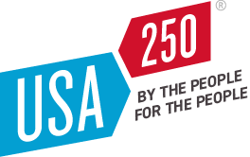
After breakfast briefing on the purposes of the United States Semiquincentennial Commission, America 250 Foundation, and the American Battlefield Trust; and the SC Liberty Trail and Liberty Trail App – Doug Bostick of the South Carolina Battleground Preservation Trust and the American Battleground Trust staff.
http://www.usa250.org/

10:00 am:
- Welcome, call Commission to Order
- Introductions of guests
- Adoption of Agenda
- Approval of September 25, 2019 Minutes
- Work on our Commission’s Vision and Mission Statements – Bill Davies, Laurie Funderburk
- Report on our Commission’s initial Executive Budget presentation on October 3, 2019 – Charles Baxley, Bill Davies, Dr. Eric Emerson, and Duane Parrish
  - SC PRT will produce the Commission a “sizzle reel” to support our budget hearings
  - The real SC budget process – what we must do to make this work
- Discussion of adoption of the SC Bicentennial Commission’s model of fostering organization of local 250th Anniversary organizations
- Education Committee report – Pam Cazel, Neil Collins, Phil Gaines, and John Slaughter, NPS
  - SCETV-NPS southern campaign videos
  - Know-It-All website for use in classrooms and potential expansion of those videos to include other sites in SC https://www.knowitall.org
  - Teaching American History in South Carolina – SCETV, SC Archives & History https://digital.scetv.org/teachingAmerhistory/index.html
- Partnership Committee report – Emily deQuincey-Newman
  - SCS DAR State Regent Elizabeth Billham and Emily deQuincey-Newman, Charles Baxley, and Dianne Culbertson
  - SCS SAR President Nat Kaminski and Charles Baxley
  - Perhaps develop a proposed Joint Resolution of Cooperation between the Commission and our Partner Organizations
- Report on other state and national 250th Anniversary organization’s plans, budgets
  - SC Society and National Society DAR – Dianne Culbertson
  - National Park Service – Dan Smith on the “NPS REV250”. Dan Smith is the Special Assistant to the National Park Service Director - 250th Commemoration.
- New federal Southern Campaign of the Revolution National Heritage Corridor bills filed – S. 2436 (SC Sens. Graham & Scott) and H.R. 3936 (SC Cong. Clyburn, Norman, Rice, Cunningham, Duncan, Timmons, Wilson) – Charles Baxley, John Slaughter
- Where are we now in SC on our Revolutionary War story product development? SC Economic Development and Cultural Heritage Tourism. SC Rev. War Cultural Heritage Tourism product development challenge – Duane Parrish, Director SC PRT
- Briefing on branding the Commission – Duane Parrish and SC PRT media team
  - Trademarks and artwork
  - New SC PRT Revolutionary War map, brochure
  - Slogans and our easy name (nickname): perhaps “SC Revolution 250th” or others
  - URLs and social media (Facebook, Instagram, Twitter, Pinterest, YouTube, etc.)
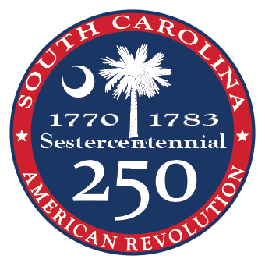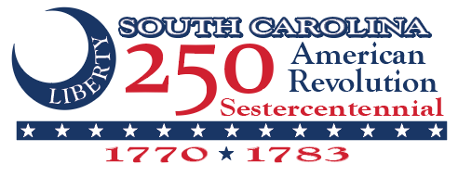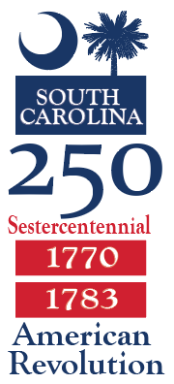
Artwork by Bryan Tate.
- Consideration of establishing a Marketing and Public Relations standing committee
- Commission’s January 2020 Strategic Planning Retreat plans – Duane Parrish and Doug Bostick
  - Strategic Planning Facilitators – Margaret and Bob Seidler
  - Lunch and Dinner Keynote Speakers
- Adoption of four regular meetings for 2020: Retreat on Friday-Saturday, January 24-25, 2020, regular meetings on Wednesdays, April 22, 2020; July 22, 2020; and October 21, 2020 at 10:00 am; locations TBA.
Noon – adjourn
Note to members of the press: The Commissioners will be together on October 29, 2019, but not in session, at 8:30 am for breakfast at Hyatt in Columbia and at the Governor’s Press Conference and Reception at the Lace House in Columbia at 3:00 pm. Should you desire to attend either event, please contact Doug Bostock at 843-743-8281 for a pass.
Nonprofit Sought to Coordinate U.S.A.’s 250th Anniversary Commemoration

November 15, 2017

WASHINGTON – Today, the U.S. Department of the Interior issued a Request for Proposal seeking a nonprofit partner to serve as secretariat and administrator of the United States Semiquincentennial Commission. The commission was established by Congress last year to coordinate and facilitate activities in 2026 to commemorate the 250th anniversary of the founding of the United States. The nonprofit will raise funds for the commission’s work, prepare reports required by Congress, and provide administrative and financial support to the commission.

The commission, acting through the secretariat, will coordinate observances and activities related to the semiquincentennial, including special events, scholarly works, artistic displays, and historical exhibits. They will consult and cooperate with appropriate Federal agencies, State and local public bodies, learned societies, and historical, patriotic, philanthropic, civic, professional, and related organizations.

The 33-member commission is comprised of eight members of Congress, 16 private citizens, and nine non-voting ex officio federal officials. The commission is required by law to submit a comprehensive report to the president no later than July 22, 2018, that includes the specific recommendations for the commemoration of the 250th anniversary and related events.

The selected nonprofit organization, acting as secretariat for the commission, will perform duties which include:

- Serving as the commission’s point of contact for all State, local, international and private sector initiatives regarding the Semiquincentennial of the founding of the United States, with the purpose of coordinating and facilitating all fitting and proper activities honoring the 250th anniversary of the founding of the United States.
- Raising all funds required for the commission’s work. All expenditures of the commission shall be made solely from these donated funds.
- Providing the commission financial and administrative services, including services related to budgeting, accounting and financial reporting, personnel, and procurement. Payments to provide these services shall be made in advance, or by reimbursement, from funds of the commission in such amounts as may be agreed on by the chairperson of the commission and the secretariat of the commission.
- Housing the administrative offices of the commission. The administrative offices must be located in Washington, DC.
- Organizing meetings for the commission. The Act states that all meetings shall be convened at Independence Hall in Philadelphia, Pennsylvania.
- Preparing an annual report detailing the commission’s activities, including an accounting of funds received and expended during the year covered by the report. The commission must submit this report once each year during the period beginning July 22, 2016 and ending on Dec. 31, 2027.

https://www.doi.gov/pressreleases/nonprofit-sought-coordinate-usas-250th-anniversary-commemoration

In May 2018, the American Battlefield Trust was chosen by the Department of the Interior to serve as the official nonprofit partner, or administrative secretariat, of the U.S. Semiquincentennial Commission. The Trust and the Commission look forward to engaging the nation – and the world – in America’s Semiquincentennial and leaving a lasting legacy. Join us on a journey 250 years in the making.
https://www.battlefields.org/america-250

On-line resources about the American Revolution in South Carolina
Daily maps of troop movements - elehistory.com/amrev/SitesEventsTroopMovements.htm
Detailed information about each battle and ever evolving military and political organization, and much more - carolana.com/SC/home.html
In the soldiers’ own words – pension affidavits detailing the service of over 23,378 individuals who fought for the Americans in the Southern Campaigns - www.revwarapps.org
Scholarly articles on the Southern Campaigns - www.southerncampaigns.org
SC Dept. of Archives & History Resources - https://scdah.sc.gov/news/2019-08/sources-researching-american-revolution-south-carolina
Battleground Preservation Organizations
The American Battlefield Trust - battlefields.org/about/revolutionary-war-trust
South Carolina Battleground Preservation Trust - scbattlegroundtrust.org

“We then marched on and joined General Williamson’s command at the Piney Woods House, now in Edgefield District. We Joined General Twiggs at or near Ebenezer in Georgia, and then proceeded to Florida. We passed the Altamaha [River] about the last of July 1776. I distinctly recollect that on reaching the far Bank of that River, a horseman made his appearance on the bank and manifested a wish to reach us, supposing him to be an express he was sent for and on reaching the Army he delivered to General Williamson dispatches containing the Declaration of Independence. General Williamson called upon Captain Lacey to open the dispatches, who done so and on discovering the contents Captain Lacey raised up both hands and exclaimed THANK GOD for this. He then read the Declaration to the officers who were about him. General Williamson wished it read to the Army to effect which the Army was formed in a Hollow Square, and to give Captain Lacey a better chance to be heard by the whole Army. General Twiggs brought up a gentle horse and held the same while Captain Lacey stood up on the saddle and read the Declaration of Independence to the whole Army at the conclusion of which there was much firing of arms and rejoicing.”
Capt. Robert Wilson, York District, SC
http://revwarapps.org/w2302.pdf

