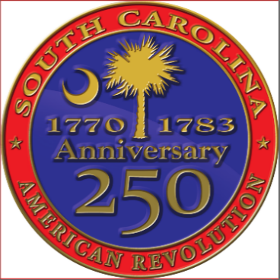
South Carolina American Revolution Sestercentennial Commission
Regular Quarterly Meeting via Webex
Monday, July 20, 2020 at 10:00 am
Agenda

Note: Our on-line Webex forum will be opened at 9:30 am to give participants a chance to get connected and to visit.
A few moments of reflection and prospective with Dianne Culbertson
Charles Baxley - Call to Order, declaration of quorum
Charles Baxley - Introductions
Charles Baxley - Adoption of Proposed Agenda
Charles Baxley - Approval of Minutes of April 20, 2020 meeting

Reports of Standing Committees
Executive Committee – Charles Baxley, chair; Bill Davies, Dianne Culbertson, Duane Parrish, Dr. A.V. Huff, and Donna Foster, acting secretary
Duane Parrish
Dr. Eric Emerson
Budget and Finance Committee – Vic Carpenter, chair; Pam Cazal, Brett Bennett, and Steve Moss
Publications Committee – Charles Baxley, acting chair; Dr. Eric Emerson, Zach Lemhouse, Brett Bennett, Guy Wallace, Jannie Harriot, Prof. Larry Watson, and Prof. Larry Rowland
David Reuwer – SC RW fully referenced SC Timeline – introduce project & committee members
Brett Bennett – SC RW centric Bibliography – introduce project & committee members
Rick Wise – RFP for referenced research – 1) SC Revolutionary Era women and 2) SC African-American soldiers of the Revolution (both sides)
- Patricia Hinton and John Marker – research on SC African-American soldiers
Recommend name change to “Publications and Research Committee” and seek a chairman
Education Committee – Sen. Floyd Nicholson – Chair; Neal Collins, Zach Lemhouse, Sarah Cunningham, Justin Lovelace, and Jannie Harriot
Marketing, Branding, and Public Relations Committee – Pam Melton Cazel – Chair; Laurie Funderburk, Duane Parrish, Dolly Chewning, Perry Baker, and Jannie Harriot
Charles – Lapel pin distribution and approve mailing cost invoice
David Reuwer – temporary brochure
Partnerships Committee – Emily deQuincey-Newman – Chair; Dianne Culbertson
Donna Foster – volunteer Nika Lowery – development of our potential partner database
Performance Evaluation (Metrics) – to be organized
Chair recommend adoption on new standing committee; seek chairman

Reports from Ad Hoc Committees
Speakers Bureau – Dr. Tray Dunaway, Director; Bill Davies, acting chair; Jannie Harriot and Donna Foster
Website Development and Operations – Vic Carpenter, Charles Baxley, and Perry Baker
Perry Baker – New Commission administrative website – artwork done – basic organization started; new website URL; new Commissioner and Key Advisors Google accounts; and new email addresses
Marjory Wentworth – SC Poet Laureate – Bill Davies
Robert Slade – Kapellmeister and composer – music militaire – Bill Davies
Museum Display Boards – Donna Foster & Charles Baxley – Development of graphics for museum display boards depicting local Revolutionary War history persons, places, events, and ideas
Charles Baxley – Description and purpose of project (in coordination with SCBPT) – demonstration model at the Morris Center for Lowcountry Heritage, Ridgeland SC
Donna Foster – Contract with graphic artist Jamie Boone
SC Liberty Trail – Update and property acquisition - Doug Bostick
Six new SC Revolutionary War parks development: Fair Lawn (Moncks Corner); Eutaw Springs; Camden (5 miles north of Camden); Hanging Rock (2 miles south of Heath Springs); Waxhaws (7½ miles east of Lancaster); and Blackstock’s Plantation (5 miles northeast of Cross Anchor) and Ft. Watson improvements – conceptual plans, lead donors, solicitors
New Business
Set next regular meeting: Wednesday, October 21, 2020 – because of Covid-19, the Chair recommends we hold another electronic meeting
Other business or reports
Adjourn

