South Carolina American Revolution
Sestercentennial Commission
Executive Committee Agenda 10:00 am June 22, 2021
Offices of South Carolina Parks, Recreation & Tourism
Room _, Edgar Brown Building, 1205 Pendleton Street, Columbia, SC

Attending via electronic connections: Commissioner Dianne Culbertson and SCBPT advisor Doug Bostick; attending in person: Duane, Bill, Charles, Donna, and Eric
10:00 am call to order
- Education Summit – July 14, 2021 – SC Dept. of Archives & History, Wachovia Room – Sen. Floyd Nicholson, Zach Lemhouse, and Charles Baxley
  - Program Goals
  - Program management: Zach Lemhouse (up front) and Charles and Donna (in back)
  - Expenses, curriculum research, handout copies, and lunch
      - Need approval of program and expenditure of $400 in non-appropriated funds
      - Small contract for existing curriculum research and quick review of existing curriculum’s contents - $500

- FY 2021-2022 Budget/Appropriation
  - Status and how to start drawing on FY 2021-2022 appropriation on July 1st
    - A SC GA joint Commissioner already tried to get mileage reimbursement
    - What approval votes and paperwork is needed and how disbursement is physically done; timing issues; who approves and codes to various accounts expenditures?

  - Contracting with SC Dept. of Archives & History or other providers for resources: office space suite (number of rooms?) including parking, security, bathrooms, and occasional use of conference rooms; office furniture, filing, and equipment; computer and software, internet, copier, scanner, telephone communications equipment, and IT support; finance; personnel; procurement; and legal services
      - Need authorization to negotiate agreement for basic office services
      - Tasks to assign to our Budget Committee

  - Personnel – job descriptions, expectations, organization and reporting
    - We’re on soft money – may need alternatives to regular state employment
        - Can we use contract employees?
    - Need authorization to develop job descriptions
    - Need authorization to initiate search process
        - Do we need approval of employment process steps?
        - Who culls applications, who interviews, and who selects?
        - How do we set reasoned salaries? Ranges?
        - How about expense reimbursements?
  - Work and funding priorities
    - Building and populating our database
    - Writing, design and layout of our periodic Committee of 99 communications newsletter
    - Executive Report - annual
    - Education Initiatives
    - Cultural Heritage Tourism – getting us ready for visitors (see IV. H. below)
      - Plans with SCBPT on developing pull offs (site identification, partnerships, acquisition, site engineering, permitting and construction, interpretation)
      - Museums and Visitors Centers local Revolutionary War boards (see IV. D. below)
      - Roadside Historical Markers inventory and adoption services - Bill Segars and Donna Foster
        - Inventory – 163 SCDAH markers visited; 19 MIA; many need maintenance
        - Starting on MIA, wounded, and orphaned markers

  - Delegation of authority for executive action and spending discretion until we are staffed and have office systems up and running
1. We have about 2 dozen small projects which need small funding: editing, peer reviews, graphics design services for papers, website development, office supplies, printing, postage, etc.
2. Expedite approval authority, bookkeeping,

- Planning for upcoming regular full Commission Meeting on Wednesday, July 21, 2021
  - Agenda items
  - In person or via videoconferencing? Best length of meeting?
  - Charles’ desire to meet in person
    - Charlestown Landing SP
    - Southern Revolutionary War Institute – York, SC
    - Loss of energy from great retreat at Hickory Knob

- Updates on ongoing projects will be available if requested:
  - Publications
    - African American SC Patriots (Prof. Patricia Hinton and John Marker) paper to graphic artist
    - “Dicey” Langston paper (Rev. Dr. Paul Wood, Jr.), passed peer review and initial edits; need second peer review and edit; then to graphics
    - Lord Rawdon’s war correspondence papers underway – Todd Braisted
    - Thomas Sumter Papers project restarted at SRWI – Zach Lemhouse, Managing Editor
    - Francis Marion Papers project

  - Administrative Website – Caroline Chambers and Eric Parton
    - Timeline – Guy Wallace
    - Bibliography – Brett Bennett
    - Speakers Bureau – Dr. Tray Dunaway

  - Convention outreach
    - Convention Booth props – Donna Foster & Jami Boone
    - We have lapel pins and temporary brochures
    - Need to start lining up appearances at 2022 events and get booth spaces and on programs
        - Camden Reenactment – Nov. 12-13-14, 2021 – Donna lining up manning
        - Society of the Cincinnati “Triennial” meeting of 600-700 members and spouses April 29 - May 1, 2022 in CHS: offer local RW tour services, presenters, and maybe a manned booth. Our liaison is Bill Marshall.

  - Morris Center local Revolutionary War people, places, and actions exhibit prototype boards – Bill Davies, Donna Foster, graphic artist Jami Boone, and local history committee

  - Agency and Partner Meetings
    - SC DOT – deputy Commissioner Leland Colvin, PE and Chad Long (Charles)
    - SC Chamber of Commerce – Bob Morgan, President & CEO
    - Colleton County – Charles Bridges, Bill Davies, and Charles Baxley
    - Greenville County – Anne Peden, Kristen Pace, and Durant Ashmore (Charles), Upstate History Museum, July 27th at 4:00 pm
    - Beaufort County – Rich Thomas with Bill Davies
    - Laurens County – Rep. Stewart Jones (Charles) – RW Visitors Center

  - SC Automobile specialty license tag – SCDMV and Perry Baker, SCPRT
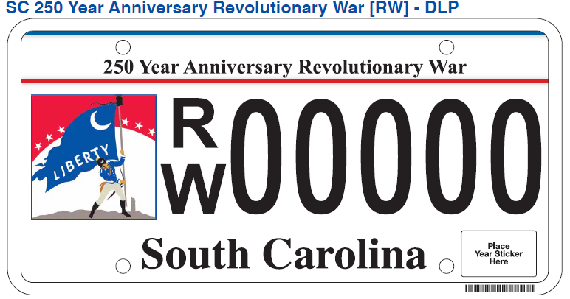
    - Artwork courtesy of SCPRT (thanks Duane)
    - $35 per tag to us; first 100 numbers reserved

  - America250 Foundation’s initial web conference – Brett Bennett, Doug Bostick, Perry Baker, and Charles
    - Charleston, SC “Signature Event”
    - “4th on Main” sponsored programs, 5 to be selected in SC
    - 20 states meeting - $10,000 each

  - Committee of 99 organizational handouts – Vic Carpenter, Zach Lemhouse, and Caroline Chambers’ team

  - Local Revolutionary Era product survey, planning, and consultation
Local cultural heritage/Revolutionary Era tourism services to our partners: readiness reviews, working with local planning teams, planning reports and getting community buy in – asset identification, asset development, and financial planning for product development, product promotion, and product delivery. Local governments are flush with Covid-19 “American Rescue Plan” money. $8.9 billion to SC with $2.6 billion controlled by the General Assembly and $1.6 billion to local governments. $3.4 billion to education and child care services, with $2.2 billion distributed by the Education Department. “The state can use money … to support the hospitality, travel and tourism industries…” AccelerateSC
    - Service offered free by SC 250th Commission to partner agencies
    - Allocation to contract for program development and training of our “experts”
      - Identification and qualification of Vendors – SC tourism infrastructure expert
      - Negotiate rates & terms
    - No one size plan fits all: provide research on local relevant (to Revolutionary Era) persons, places, and events
      - Identification and qualification of vendors – SC RW Era historian
      - Negotiate contract rates & terms
    - Listen, provide outsider validation of their interpretative and product visions, share what others have successfully done in product development and execution, offer encouragement, and help bridging local factions to develop a broadly-supported plan including involving local governments, interested citizens, and the business community
      - We need an “Ambassador” or two to make the local contacts, deliver our messages, resolve problems, and do follow-up
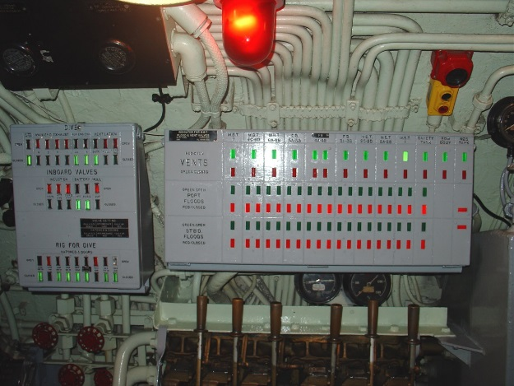
    - Develop an internal “Christmas tree” for all Counties’ readiness to serve RW Era cultural heritage tourists: where got act together vs. where clueless or don’t care
Submarine’s “Christmas Tree” a simple and quick GUI to see if the submarine is sealed for a dive.

  - Follow up on Commission’s branding musique militaire with capellmeister Robert Slade – Bill Davies
    - Drum & Fife Corps recording session

