South Carolina American Revolution
Sestercentennial Commission
Regular Commission Meeting Agenda 10:00 am July 21, 2021
Offices of South Carolina Parks, Recreation & Tourism
Room 252, Edgar Brown Building, 1205 Pendleton Street, Columbia, SC

10:00 am - A few moments of reflection and prospective with Chaplain Dianne Culbertson
Charles Baxley - Call to Order and Introductions
Bill Davies - declaration of quorum; Donna Foster - compliance with FOIA
Charles Baxley - Adoption of Proposed Agenda
Charles Baxley - Approval of Minutes of April 23, 2021 meeting
- New NPS representative – introducing Diane Bramble, Southern Campaign of the American Revolution Parks Group Superintendent. See Attachment 1.

- Publications Committee - “Real stories, real experiences.” – Charles Baxley, acting chairman.
Update on the new Commission Administrative Website - Tour Alpha version of Commission’s new administrative website at www.southcarolina250.com
Research Papers underway
i. SC African-American Men and Women of Note in the Revolution Project – submission by Dr. Patricia M. Hinton and John L. Marker, Jr., “South Carolina Free Men of Color in the American Revolution” peer reviewed, recommended for publication, and approved by the Commission for publication.

ii. Prototype research paper on legendary Revolutionary Era Women in South Carolina – Rev. Dr. Paul Wood, Jr. has completed his paper on Revolutionary War heroine “Dicey” Langston. It has been peer reviewed and recommended for publication.

3. Marketing, Branding, and Public Relations Committee – Commissioner Pam Cazel, chair; professional advisors Perry Baker and Dolly Chewning of SC PRT
- 2021 Projects:
    - Convention Booth Display Project – Donna Foster, project coordinator: drawing attention and promoting our missions. An attention grabbing convention display, banners and stands, flags, etc. with appropriate graphics. Jami Boone, our contract graphic artist.
    - “Temporary” SC 250th Brochure – Printed and available. Copy attached. Please let Charles Baxley know how many brochures you want.
    - SC 250th lapel pins: we have about 100 in inventory; please let Charles Baxley know how many you want.
- FY 2021-22 Building the basics/foundations of our Marketing Program

- Budget and Finance Committee – Committee Chair Commissioner Vic Carpenter:
  - Suggestion that we add a Treasurer as a Commission officer and to the Executive Committee
    - Make Chairman of the Budget and Finance Committee the Commission’s Treasurer
  - Briefing on SC government procurement process (Dr. Eric Emerson)
  - Report on our FY 2021-2022 budget
    - Attached copy of our detailed budget as approved by this Commission. See attachment 2.
    - Attached copy of budget as submitted and approved by the General Assembly and Governor. See attachment 3.

- Education Committee – Committee Chair Commissioner Floyd Nicholson
Report on Education Summit – July 14, 2021 at SC Dept. of Archives & History - Zach Lemhouse, moderator and Tanner Wise (existing SC relevant curriculum research)
Commission’s goal: Educate South Carolinians and the world about South Carolina’s roles in the American Revolution.

Program’s Goals:
- How should we better define the Commission’s education goals?
- How do we achieve these goals?
- Tactics
- Curriculum & classroom resources; external resources
- Published Standards
- Teacher Education Workshops
- Measurable results
- What are other organizations doing to accomplish the same goals?
- What is SC teaching on the American Revolution in general and SC in particular now?
  - 2011 SC Social Studies Academic Standards
  - 2020 South Carolina Social Studies College- and Career-Ready Standards
  - James Edwards Civics Education requirements
- Should we join with other like-minded efforts?
6. Commission Administration
A. Donna Foster – Please send additions and corrections of local historical societies, museums, and visitor’s centers contact information for our database. This database will be used to notify the broader public of Commission events and resources and other activities of the Committees of 99.
B. Charles – Attached is a current copy of the various standing and ad hoc Committee assignments. Please review it and send along any corrections. Please let Charles know if you want to join or switch Committees. Volunteers may sign up for any Committees they wish. If you think we need to clarify which Committee has jurisdiction over any specific issue or project, please let me know. See attachment 4.
C. Report on Charles Baxley and Bill Davies meeting with Dr. Eric Emerson and the SC Dept. of Archives & History’s finance team led by Bernice Cooper-James, MBA.

D. Charles and Bill are in discussions with Dr. Emerson about SC Department of Archives and History furnishing the SC 250th Commission with: office space suite including parking, security, bathrooms, and occasional use of conference rooms; office furniture, filing, and equipment; computer and software, internet, copier, scanner, telephone communications equipment, and IT support; finance; personnel; procurement; and legal services.
E. Recommendation on Commission’s staffing
Dr. Emerson recommended that the Commission hire two temporary employees to start up the Commission’s work as soon as possible until more permanent staff can be located, appropriately vetted, and retained. This process may have to go through state procurement and may easily take three months. Chairman Baxley concurs and adds that time is of the essence especially with all of the COVID funding flooding governmental coffers which can be used for tourism development projects. Local governments are flush with Covid-19 “American Rescue Plan” money. $8.9 billion to SC with $2.6 billion controlled by the General Assembly and $1.6 billion to local governments. $3.4 billion to education and child care services, with $2.2 billion distributed by the Education Department. “The state can use money … to support the hospitality, travel and tourism industries…” AccelerateSC
i. Recommendation that the Commission hire two full-time employees, one Office Manager and one Executive Director, on contract from an agreeable start date in the fall of 2021 through June 20, 2022 (funding expiration date)
ii. Recommendation to allow Executive Committee to draft and approve the job descriptions
iii. Recommendation to allow Executive Committee to advertise for, to interview and screen, and hire temporary employees until final RFP can be drafted, submitted, and approved through State Procurement
iv. Recommendation to allow Executive Committee to advertise for, to screen and interview, and hire contract employees under an RFP as submitted and approved through State Procurement
v. Recommendation to allow Executive Committee to negotiate compensation, any benefits, and expense accounts for both employees in line with our approved budget.
vi. Authorize Executive Committee to negotiate a personal service contract with the South Carolina Battleground Preservation Trust or some other suitable not-for-profit corporation to provide Commission’s contracted employees.

- Revolutionary Era Museum Boards of the local area project – featuring significant people, places, and events – this is a prototype project. Progress report from VC Bill Davies (project co-managers Ivan Bennett and Joe Riddle):
  - Bill Davies: Report on the Morris Center for Lowcountry Heritage in Ridgeland local Revolutionary Era history museum graphics prototype project.
  - Recommendation: From appropriated funds, increase funding to $5,000 per exhibit to cover local Revolutionary Era people, battles and skirmished, and places. The grant will fund research, design, graphics and artwork, and exhibit manufacturing costs. For current FY award local Revolutionary Era exhibit grants to 10 local history museums and visitors centers; provided that the Morris Center grant will be one of the funded projects. Museums and Centers will have to agree to display the exhibit at least through 2033 though it may be repaired and updated.

- Partnerships Committee – Emily deQuincy-Newman, Chair – recruiting, establishing, and fostering enduring mutual relationships with our partners and allies, individuals, and with non-governmental and governmental organizations
  - “Committee of 99” – local planning committees to plan local Revolutionary War educational programs, 250th celebrations, and cultural heritage tourism infrastructure.
    - Meeting with Colleton County group – Charles Bridges, Bill Davies and Charles Baxley
    - Meeting with Greenville County group (July 27th) – Dr. Anne Peden, Jim Scott, Kristen Pace, Durant Ashmore, and Charles Baxley
    - Meeting with Beaufort County group – Bill Davies
    - Discussions with SC Sen. Shane Martin, Spartanburg and Union Counties; Suzanne Brooks, Executive Director of the Spartanburg County Historical Association; children’s book author Sheila Ingle; and Charlie Gray. Meeting with Spartanburg County group (July 28th).
    - Discussions with Rep. Stewart Jones and others, Laurens County

  - Report on Charles’ discussion with Phil Gaines about developing a small team of genuinely helpful experts to help local Committees of 99 review and get their communities and sites ready for Revolutionary War cultural heritage tourism, and to work together to obtain funding for needed improvements. The goal is to conduct local Revolutionary Era product surveys, help with planning of local cultural heritage/Revolutionary Era tourism for our Committee of 99 partners. This service may include readiness reviews, working with local cultural heritage/Revolutionary Era tourism planning teams, helping with reports, and getting community buy in, asset identification, asset development, and financial planning for product development, product promotion, and product delivery.

  - Developing handout packages for establishment of local Committees of 99 – underway with Commissioner Vic Carpenter, chair.

  - City of Travelers Rest, SC – Mayor Brandy Amidon has recommend that her City become the SC 250th Commission’s first municipal partner. They are currently fundraising to place a sculpture by Greenville artist Nick Ring of Dicey Langston on their Town Square. [Photo of a small clay model of “Dicey” to the left.]

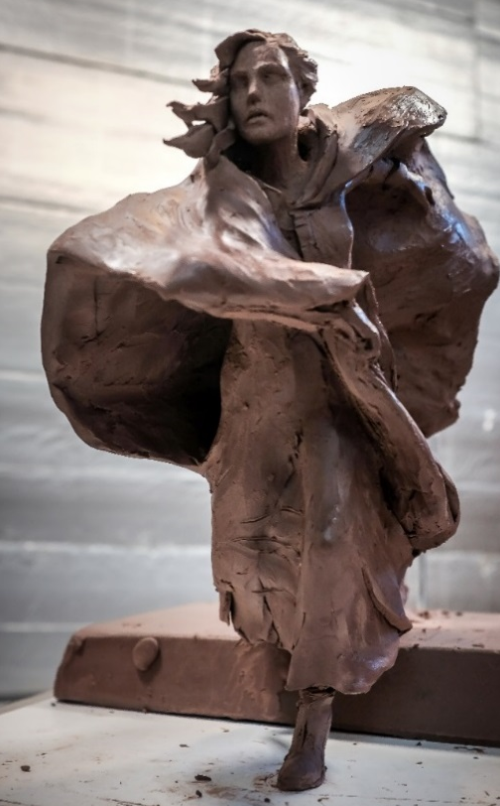
Recommendations: 1) ask Mayor Amidon to form a local Committee of 99. 2) Commission grant $1,000 to the City of Travelers Rest “Dicey” Langston sculpture project.

  - Pickens County - Commissioner Neal Collins report on funding to restore Gen. Andrew Pickens’ gravesite at the Old Stone Church graveyard in Clemson. For more on South Carolina’s Parks and Recreation Development (PARD) fund see www.scprt.com/grants

Recommend that the Commission award grants to any South Carolina county forming, organizing, and staffing a Committee of 99 to plan local Revolutionary War educational programs, 250th celebrations, and cultural heritage tourism infrastructure. That the individual County Committee of 99 grants be $3,000.

  - SC Chamber of Commerce – Bob Morgan, new President & CEO – met with Charles Baxley

  - Meeting with SC Department of Transportation – Charles Baxley met with Leland D. Colvin, PE, Deputy Secretary for Engineering at SC DOT and their Director of Environmental Services (archaeologist) Chad Long concerning several SC 250th projects:
    - Developing an interpretative pull off at Sampit River Bridge – Gen. Francis Marion battlefield in Georgetown County
    - Developing sample pull off sketches for safety and viewing Revolutionary sites which will not become parks – building safe tourism infrastructure (See attachment 6)
    - Specially marking SC’s colonial highways which are still in use today

Noon to 1:00 pm - Break for lunch – box lunch and beverages provided

- Liberty Live’s American Revolution educational programs – Dr. Tray Dunaway and Tom Oblak
Commissioner Brett Bennett - Liaison with reenactor leadership and event planners on upcoming 250th Anniversary major reenactments.
Battle of Camden education day and battle reenactment – SC 250th Commission will share have a free booth Nov. 12-13-14, 2021 with the Liberty Trail, SC BPT, and the Southern Revolutionary War Institute (we need volunteers to man booth – Donna coordinating)
- South Carolina Battlefield Preservation Trust and SC Liberty Trail - David P. Reuwer, Vice President, report on the Liberty Trail’s electronic app, land acquisition, and the status on development of six new Revolutionary War parks at: Waxhaws, Hanging Rock, Camden, Eutaw Springs, Fair Lawn Plantation, and Blackstock’s Plantation.
    - David’s reading recommendation: Building a Bridge to the 18th Century: How the Past Can Improve Our Future by Neil Postman

- Commissioner Brett Bennett - report on the US Semiquincentennial (250th) Commission and their America 250 Foundation.
    - Charleston, SC statutory “signature” event – July 4, 2026
    - Five other SC towns and cities “Fourth on Main” sponsored events – July 4, 2026
    - Possible $10,000 grant – maybe?

- SC Revolutionary Era approved Roadside Historical Markers inventory and adoption services Report from Bill Segars and team, and Donna Foster – see attachment 7
        - Inventory – 163 SCDAH markers visited, GPSed, and photographed; 19 MIA; many need maintenance
        - Inventory expanded to other Revolutionary Era markers, private, and non-SC DAH approved
        - Starting on locating and talking with sponsors of MIA, wounded, and orphaned markers
        - A map and information about all Revolutionary Era approved markers is on the Commission’s new website

- Commissioners Laurie Funderburk/Vic Carpenter – Update on the construction of the new Revolutionary War Visitors Center in Camden – its function and purposes: 70% SC Backcountry in the Revolution and 30% Camden and Kershaw County. Rickie Good named new director. Exhibits and displays being finalized. Operational budget from City of Camden and Kershaw County. Historic Camden will operate the gift shop. There is 125 person meeting space available. Getting local towns and sites ready for cultural heritage tourist driven by the 250th Anniversaries.

- Acting Commissioner ex officio and Director of South Carolina Department of Archives and History: Dr. Eric Emerson
  - SC ArchSite – http://www.scarchsite.org – update on adding known Revolutionary War sites to the GIS archaeological resource database: protecting SC’s Revolutionary War archaeological resources.
  - SHPO’s SC 250th Role
  - SC Archives’ SC 250th Plans and Role

- Commissioners Reps. Neal Collins and Steve Moss, Pam Cazal, and SC PRT Perry Baker, our SC DMV single point of contact (Dolly Chewning pinch-hitting for Perry)
SC motor vehicle license plate law – SC Act No. 11 ... see Attachment 5 below https://www.scstatehouse.gov/sess124_2021-2022/bills/3501.htm
- Volunteer opportunities – manning the SC 250th booth – Donna Foster coordinating, for dates, events, and places, please see attachment 8

- Doug Bostick – report on US Bill H.R. 1286 to establish in the States of North Carolina and South Carolina the Southern Campaign of the Revolution National Heritage Corridor.

- Chairman’s report
  - Covid-19 is losing ground (we hope), Bill Davies and Baxley are back on the live speakers circuit
    - Working on developing partnerships and local Committees of 99
    - Two themes: Local Economic Development through Cultural Heritage Tourism and Local Revolutionary Era Education – telling our stories and changing attitudes

- Upcoming 2021 regular Commission meetings:
  - Wednesday, October 20, 2021 at 10:00 am in person (unless Covid-19 Δ variant cases have substantially resurged) – asked to meet at Charles Town Landing State Park.
  - Concern of a loss of time and momentum due to Covid – do we need to plan another retreat?
  - We have an offer to do a morning regular meeting and tour a Revolutionary War battlefield in the afternoon. Would this be of interest to the Commission?
Other items of business
Adjourn by 3:00 pm

Attachment 1

Diana Bramble Named Superintendent of Cowpens National Battlefield and

Kings Mountain National Military Park

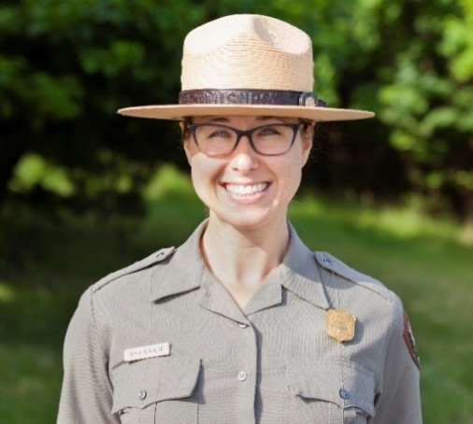
News Release Date: February 10, 2021 (NPS Photo)
ATLANTA — Today, National Park Service (NPS) South Atlantic-Gulf Regional Director Stan Austin announced the selection of Diana Bramble as the new superintendent of South Carolina’s Cowpens National Battlefield and Kings Mountain National Military Park, effective March 14. In her role, Bramble will also oversee management of Overmountain Victory National Historic Trail and Ninety Six National Historic Site. Bramble has managed the four units on temporary assignment since September.
“Diana brings experience caring for iconic landmarks with complex operations and stories critical to America’s advancement as a democratic society,” Austin said. “As we prepare to mark the 250th anniversary of the American Revolution, Diana is wholly committed to protecting the parks’ treasured resources and enhancing collaboration with staff, visitors, partners and gateway communities.”
Bramble said, “I am incredibly grateful to have been selected for this opportunity. The staff here are profoundly dedicated to their work as caretakers of America’s heritage. It is an honor to help lead the park as a team towards an exciting future with many opportunities for partnership and engagement in anticipation of the 250th commemoration of America’s founding.”
Bramble began her NPS career in 2011 as the supervisory horticulturist for Rock Creek Park in Washington, D.C. with responsibility for horticulture, arboriculture and grounds management. Four years later, she became chief of maintenance at National Capital Parks-East, where she has managed the entire facility operations and project management portfolio for a vast set of resources spanning 8,000 acres, including historic homes, commuter parkways, earthen and masonry fortifications, working farms, marinas and a campground. Prior to joining NPS, Bramble worked six years at the Smithsonian Institution as a horticulturist.
Originally from the Eastern Shore of Maryland, Bramble holds a Bachelor of Science degree in natural resources from University of Maryland and a Master of Professional Studies in sustainable landscape design from George Washington University. She is a graduate of the NPS Facility Manager Leaders Program and now serves as a program mentor. In 2019, Bramble was awarded the NPS National Capital Area Facility Manager of the Year honor.
Outside of work, Bramble enjoys spoiling her niece and nephews, spending time outdoors, traveling and strength training.
https://www.nps.gov/cowp/learn/news/2-10-21-supt-annct.htm
Attachment 2
FY 2021-2022 budget as approved by this Commission

Critical Task |  | Approved Budget
Communications
 | Printed materials | $ 12,000.00
 | Website development & URLs | $ 6,000.00
 | Telephones & computer system, software | $ 6,000.00
 | Public media support | $ 24,000.00
 | Postage & shipping | $ 3,000.00
 | Quarterly newsletters to stakeholders | $ 6,000.00
 | Development of communications database | $ 8,000.00
Administration
 | Executive | $ 125,000.00
 | AA | $ 60,000.00
 | Admin. Tourism Conferences | $ 4,000.00
 | Administrative Travel | $ 9,000.00
 | Office rents | $ 18,000.00
 | Office furniture & equipment rents | $ 10,000.00
Branding
 | Graphics artist | $ 9,000.00
 | TM registrations | $ 2,000.00
Commissioners
 | Travel | $ 15,000.00
 | National and Regional Meetings | $ 16,000.00
Support of Site (Product) Development
 | RW Site Acquisition & Pull Off Development | $ 450,000.00
 | Site Development & Interpretation | $ 100,000.00
 | Marketing | $ 25,000.00
 | Operations & Maintenance | $ 20,000.00
Support of SC Rev. War Research |  | $ 80,000.00
 | Thomas Sumter papers
 | Francis Marion papers
 | John Rutledge papers
 | SC Militia Officers
 | SC Loyalist Claims
 | SC Battle Maps
 | Site archaeology
Support of Publications |  | $ 60,000.00
 | Battlefield Guides
 | American Leadership Biographies
 | Impacts on Loyalists
 | Impacts on Native Americans
 | Impacts on enslaved peoples
 | Publication access via Internet
Development and operations of speakers bureau |  | $ 15,000.00
Support of SC Rev. War Conferences and Symposia |  | $ 10,000.00
Museum and Visitors Center Rev. War boards |  | $ 60,000.00
 | Offer a package of a site tour board
 | and a local Revolutionary War action board
Support of K-12 School Curriculum & Materials |  | $ 80,000.00
 | School SC Rev. War posters
 | SCETV school projects
Development of Local 250th Commissions |  | $ 140,000.00
 | Outreach & communications
 | Local project grants
Promotion of local commemorative activities |  | $ 20,000.00
 | public art, performances, living history
Identification & Marking SC Colonial Roads |  | $ 15,000.00
New Roadside Historic markers & maintenance |  | $ 38,000.00
 | Total Budget Request | $ 1,446,000.00

Attachment 3
FY 2021-2022 budget as approved by The South Carolina General Assembly

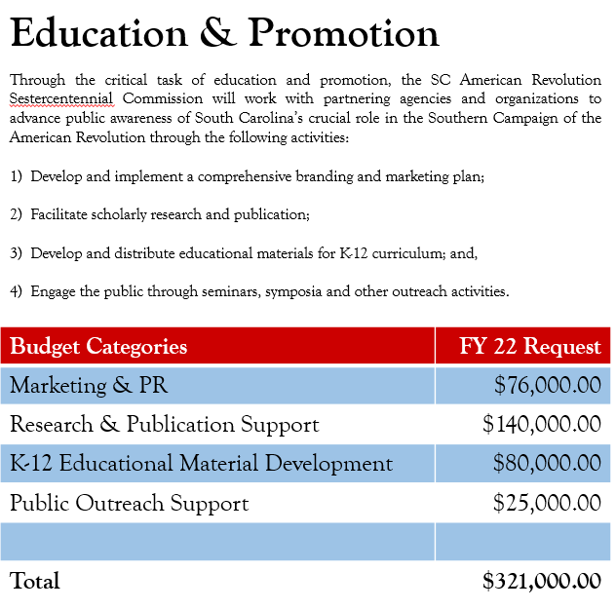
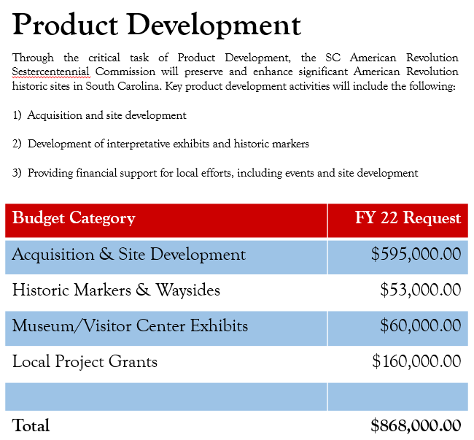
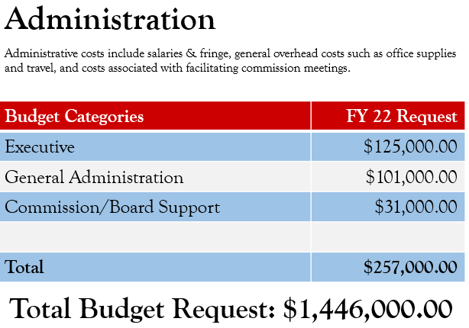

Attachment 4
SC 250th Commission Committee Assignments [as of July 18, 2021]
Charles B. Baxley – Chairman
Bill Davies – Vice Chairman
Dianne Culbertson – Chaplain
Duane Parrish – (Director SC PRT) statutory Executive Secretary
Dr. A.V. Huff – (Chair, SC A&H Board) statutory Assistant Executive Secretary
Donna Foster – (SC A&H Foundation) acting secretary; advisors Dr. Eric Emerson (Director SC Dept. A&H) and Doug Bostick (President SC BPT)

Standing Committees

Education Committee – Sen. Floyd Nicholson – Chairman; Neal Collins; Zach Lemhouse; Justin Lovelace; Kevin Kerr; and Jannie Harriot
Partnerships Committee – Emily deQuincey-Newman – Chairperson; Dianne Culbertson
Budget and Finance Committee – Vic Carpenter, Chairman; Pam Cazal; Brett Bennett; Laurie S. Funderburk; and Steve Moss
Marketing, Branding, and Public Relations Committee – Pam Melton Cazel – Chairperson; Laurie Funderburk; Duane Parrish; Dolly Chewning; Perry Baker; and Jannie Harriot
Publications Committee – Charles Baxley, acting chair; Dr. Eric Emerson; Dr. Dan Tortora; Zach Lemhouse; Brett Bennett; Guy Wallace; Jannie Harriot; Prof. Larry Watson; Dr. Fritz Hamer; and Prof. Larry Rowland
Performance Evaluation (Metrics) – Laurie S. Funderburk – Chair; Tom Oblak
Ad Hoc Committees
Speakers Bureau – Dr. Tray Dunaway, Director; Bill Davies, acting chair; Jannie Harriot and Donna Foster
Historical Markers Survey – Bill Segars, chair; Dr. Fritz Hamer; Bill Marshall, Guy Wallace
Website Development and Operations – Vic Carpenter, Charles Baxley, Perry Baker
Museum Local Revolutionary Era Display Boards – Charles Baxley, Doug Bostick, Donna Foster
Morris Center for Lowcountry Heritage Museum Local Revolutionary Era Display Boards project – Bill Davies with project co-directors Isaac Bennett and Joe Riddle: Jami Boone, project graphics artist; Bill Davies, Donna Foster, Tamara Herring, Executive Director, Morris Center and Kayleigh Vaughn, Director of Exhibitions and Programs of the Morris Center; Dr. Larry Rowland, Cheryl Oliver, Joan Rountree, Heather Hodges, Doug Bostick, and Bill Whitten
Darlington County Museum Local Revolutionary Era Display Board project – Bill Segars, Brian Gandy, Charles Baxley
Relationship Manager – SC Humanities – Laurie S. Funderburk
US 250th Commission and Foundation – Brett Bennett
SC Revolutionary Era Timeline – referenced David P. Reuwer Chair, Guy Wallace, Guy Higgins
SC Revolutionary Era Bibliography – Brett Bennett, Chair, Elaine Rohr, SC Archives,
Administrative database – Donna Foster
Key Advisors and Volunteers
J. Brett Bennett, businessman; Perry Baker and Dolly Chewning, SCPRT media; Zach Lemhouse, historian; Diane Bramble, NPS; Douglas W. Bostick, SCBPT, historian and preservationist; David P. Reuwer, Esq. historian and SCPBT officer; W. Eric Emerson, PhD, Director, SC Dept. of Archives & History; Guy Wallace; Dr. Dan Tortora, teacher, author, historian; History Profs. Larry Watson, Jeff Dennis, Larry Rowland, and Able Bartley; historians Todd Braisted, Rick Wise, and Dr. Fritz Hamer; Bill Segars, general contractor, photographer and historian; Dr. Ken Lewis, archaeologist; and Eric Barnes, pod-casts.

Attachment 5

Specialty SC Automobile License Plates
(R17, H3501)
AN ACT TO AMEND THE CODE OF LAWS OF SOUTH CAROLINA, 1976, BY ADDING ARTICLE 148 TO CHAPTER 3, TITLE 56 SO AS TO PROVIDE THE DEPARTMENT OF MOTOR VEHICLES MAY ISSUE TWO HUNDRED FIFTY YEAR ANNIVERSARY REVOLUTIONARY WAR COMMEMORATIVE SPECIAL LICENSE PLATES.
Be it enacted by the General Assembly of the State of South Carolina:
Special license plates
SECTION 1. Chapter 3, Title 56 of the 1976 Code is amended by adding:
“Article 148
Two Hundred Fifty Year Anniversary Revolutionary War
Special Commemorative Special License Plates
Section 56-3-14810. (A) The Department of Motor Vehicles may issue special commemorative motor vehicle license plates commemorating the two hundred fiftieth anniversary of the American Revolution to owners of private passenger carrying motor vehicles or motorcycles registered in their names. The biennial fee for this commemorative license plate is the same as the fee provided in Article 5, Chapter 3 of this title.
(B) The South Carolina Revolutionary War Sestercentennial Commission shall submit to the department for approval the design, emblem, seal, logo, or other symbols it desires to be used for this special license plate.
(C) This special license plate is exempt from the provisions contained in Section 56-3-8100.
(D) The production of this special license plate will cease January 1, 2033.”
SC Automobile specialty license tag – SCDMV and our project coordinator, Perry Baker of SCPRT
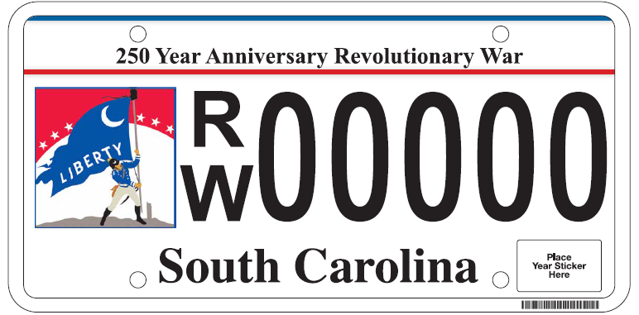
    - Artwork courtesy of SCPRT (thanks Duane) and Pam Cazal

    - The cost to the consumer to purchase the plate is $35 correct? Perry: The fee is the regular registration fee $40 for cars and trucks based on Gross Vehicle Weight.
    - At what point will the new plate be available to the general public for purchase? Perry: The plate will be available January 1, 2022 and will cease production January 1, 2023.
    - How does the Commission assign or designate the low number plates (first 100 plates that were set aside). Is there a form they would fill out and submit? At what point can those designated numbers be requested? Does the numbering start with 0000 or 0001? Perry: The reserved range will be 1-100. The Authorized Agent will be provided a spreadsheet to make plate number assignments. Applications for reserved numbers must be processed by mail at the DMV HQ. Applicants will use the attached Reserved Application. Note: She didn’t attach the Reserved Application in her email, so I will follow up with that. Perry
    - What is the process for the money from plate purchases to get from DMV to the Commission? And is that amount per plate the entire $35 or just a portion? Perry: The legislation authorizing the plate does not require an additional specialty fee or allocate funds to the commission from SCDMV.

Attachment 6
SC American Revolutionary 250th Commission pull off development and interpretation projects
To help South Carolina get ready for the 250th Anniversary cultural heritage tourism SC 250th anticipates we will seek to sponsor joint ventures (with DOT, counties, cities, etc. to leverage our funds) of couple of prototype site pull offs to work out idealized design parameters and interpretation plans. Some sites deserve serval pull offs, like Burdell’s Plantation to Eutaw Springs, and others can be one and done sites. Having them geographically dispersed helps with the politics, and picking the proverbial low hanging fruit helps with partnership development.
Developing interpretative pull offs would to enhance the SC Liberty Trail at sites where there are no existing parks, interpretation, and none planned.
Here is a potential highway pull off site list (sites in no particular order)
- Thomson/Belleville/Ft. Motte/Big Glade (?) [(?) indicates sites not precisely located]
- Fish Dam Ford [state agencies already own the property]
- Hammond’s Old Store (?)
- Avenue of the Cedars
- Black Mingo
- Blue Savannah
- Stono Ferry
- Shubrick’s Plantation
- Cary’s Fort (?)
- Coosawhatchie
- Tearcoat Swamp (?)
- Mt. Hope Swamp
- Eutaw Springs
- Earle’s Ford
- Rugeley’s Mill/Claremont and Rugeley’s Barn
- Hayes’ Station [not on a highway]
- Sumter’s Nelson’s Ferry Home and Great Savannah (?)
- Beattie’s Mill (?)
- Long Canes (?)
- Great Cane Break (?)
- Actual Musgrove Mill
- Tar Bluff [not on a highway]
- James Williams’ Fort (?) [not on a highway]
- Sampit River Bridge
- Andrew Pickens’ Ring Fight (?)
- Andrew Williamson’s home and fort (?)
- Rocky Mount
- Alexander’s Old Field (Beckhamville)
- Mobley’s Meeting House
- Wofford’s Iron Works
- Hill’s iron Works

- Special sites which need an especial delicate touch: Biggin Church ruins, Mepkin, Francis Marion’s, Thomas Sumter’s, Andrew Pickens’, and Isaac Hayne’s graves
- Some existing parking lots and pull offs that just need stepped up interpretation: Wadboo Bridge, Lower Bridge, Wide Awake Plantation (Stono), Saltcatcher (Patterson’s) Bridge, Ft. Thicketty (Ft. Anderson), Dunham’s Bluff/Snow’s Island, Quinby Bridge, Purrysburg, Ft. Galphin (Ft. Dreadnaught)
- Another list of sites for a simple roadside historical marker (another good joint venture opportunity: Martintown, Grindal Shoals, Wiggins Hill (?), several Mt. Pleasant sites (SC Navy shipyard, batteries, barracks/prison, powder magazine) ...

We will discuss with SC DOT some general pull off design parameters, physical size, safety, drainage, etc. and how you would like to structure our relationships with partners, if any, on this project.
Initial staff work should include general land, parking size and access requirements, turn radius, sight line considerations, and costs estimates. Identification of sources of potential funding for land acquisition, engineering, and on-site interpretation should also be examined. A pull off plan book would be useful.
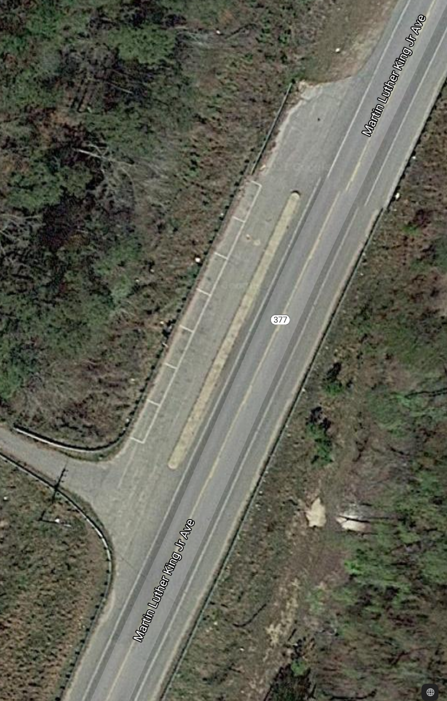
A good example is the pull off on SC Hwy 377 (Martin Luther King, Jr. Avenue) just below Lower Bridge (Black River), near Salters, SC. This pull off is fairly simple, will accommodate two buses or 10 automobiles, and is accessible either way of travel, but was fairly expensive since it is on an elevated causeway.

States have been building pull offs for scenic sites for years.

Attachment 7

American Revolution Historical Markers Inventory Project
7/19/21
What started in April of 2020 to find 185 SCDAH American Revolutionary Roadside Historical markers has now grown to 231 roadside markers. Additionally, in an effort to draw more attention to other American Revolutionary sites and monuments in South Carolina, 235 more sites have been added to this project, for a total of 466 sites. We feel that these monuments or sites are valuable in showing the important part that South Carolina played in winning the American Revolution. One of our main goals through this inventory project is to make the location of these sites available to locals and the many visitors that are expected to come to South Carolina.
To date, with a team of volunteers we have found, photographed and researched 339 of these 466 sites. Hopefully by the first part of 2022, we will complete this list. Even with an incomplete list we have moved into other areas of what to do with the collected information. We realize that collected information is no better than how that information is disseminated.
We are currently working on two ways to put this information to work:
- Guy Wallace is working with Caroline Chambers in putting these historical sites on a Goggle Mapping program that can be interacted with the South Carolina American Revolution Sestercentennial Commission’s website when it becomes open to the public. With one of the main reasons for finding these sites being collecting exact GPS coordinates, the best way to pass this information on is with a map. Addition information to be included on this map will be related websites and photographs of each site that should peak a potential visitor’s interest to travel to these historical locations.

- Donna Foster is beginning to work with our “problem SCDAH markers”. All of the found markers have been graded as to their appearance condition. If we are going to encourage visitors to come see our Roadside Historical Markers, they need to be in place and they need to be in good condition. Unfortunately we have 26 missing markers and many that are in substandard condition, or at least in a condition that we’re not real proud of. Donna’s main focus will be to contact sponsoring agencies to encourage repairing or replacing their “problem markers”. If that contact proves to be non productive, then a list of “orphan markers” will be presented to the Commission for future discussion.
If you have any comments or questions concerning the Historical Markers Inventory Project or to supply us with information concerning historical sites in your area feel free to contact Bill Segars at billsegars@gmail.com, we’re all in this together.

Attachment 8

Need SC 250th Anniversary Booth Presence and Volunteer Manning

Need volunteers
        - 19th Francis Marion Symposium, Manning, SC - Oct. 22-23 https://clarendonmurals.com/symposium
        - Rev. War Visitors Center at Camden - Nov. 6 morning program SC A&H Foundation program – (presenters Eric Emerson and Bill Davies) - Donna Foster lined up program
        - Hobkirk Hill Reenactment (10 miles NE of Camden) - Nov. 12-13-14, 2021 - Donna lining up booth manning
https://www.continentalline.org/CL/wp-content/uploads/Event_Info/2021/Battle-of-Hobkirks-Hill-Camden-2021.pdf
        - SC A&H Foundation Annual Revolutionary War Symposium in Columbia - Dec. 4, Donna lining up program https://scarchivesandhistoryfoundation.org/wp-content/uploads/2021/06/BrochureARS2021.pdf

Probably joint venture table with SC Battleground Preservation Trust, The SC Liberty Trail, and the Southern Revolutionary War Institute

