South Carolina American Revolution
Sestercentennial Commission
July 21, 2021 10:00 AM
Offices of South Carolina Parks, Recreation & Tourism
Room 252, Edgar Brown Building, 1205 Pendleton Street, Columbia, SC

Meeting Minutes

Present: Mr. Charles Baxley, Mr. Brett Bennett, Mr. Doug Bostic (by phone), Mr. Neal Collins, Mrs. Dianne Culbertson, Mrs. Pam Cazel, Mr. Vic Carpenter, Mr. Bill Davies, Mrs. Laurie Slade Funderburk, and Ms. Jannie Harriot.

Also Present: Mr. Bill Marshall, Dr. Eric Emerson, Ms. Diane Bramble, Mrs. Dolly Chewning (by phone), Dr. Tray Dunaway, Mrs. Donna Foster, Mr. Zach Lemhouse, Mr. David Reuwer, Mr. Guy Wallace, and Mr. Tanner Wise.

Chaplain Dianne Culbertson opened with words of reflection and a prayer.

Chairman Baxley called the meeting to order and introduced the commissioners and guests.

Mr. Davies – Made the declaration of quorum
Mrs. Foster – Confirmed we are in compliance with FOIA requirements

Adoption of Proposed Agenda – Mr. Davies made a motion to accept the agenda as presented. Mrs. Culbertson seconded the motion. There was no discussion. All approved.

Approval of the Minutes of the April 23, 2021 meeting – Mr. Davies made a motion to approve the minutes of the April 23, 2021 meeting as presented. Mrs. Culbertson seconded the motion. There was no discussion. All approved.

New National Park Service Representative – Mr. Baxley introduced Diane Bramble, Southern Campaign of the American Revolution Parks Group Superintendent. Ms. Bramble spoke about National Park Service (NPS) programs and activities. Mr. Baxley said the SC 250th should work closely with the NPS and their American Revolution parks located in South Carolina. See Attachment 1 for additional information.

Publications Committee - Mr. Baxley reported that the new Commission administrative website is evolving as we collect more information. The timeline that Mr. Guy Wallace and others are developing, a sample Bibliography that Mr. Brett Bennett and others are developing are now on the website. A map of the South Carolina Revolutionary Era roadside historical markers with a location and explanation of the persons, places, and events commemorated and other Revolutionary Era markers is also available. These markers are from a variety of sources including those approved by the SC Department of Archives and History, and others placed by the DAR, local governments, private individuals, etc. Photos of the markers are available and will be linked. He encouraged everyone to tour the alpha version of the website at www.southcarolina250.com. There will be a separate public website developed in cooperation with SC PRT for marketing purposes. Caroline Chambers discussed with social media options for the SCARSC with SCPRT brand manger Devin Whitmire and both agreed there is not enough activity to efficiently use social media successfully at this time.

Research Papers underway:
SC African-American Men and Women of Note in the Revolution Project – submission by Dr. Patricia M. Hinton and John L. Marker, Jr., “South Carolina Free Men of Color in the American Revolution” peer reviewed, recommended for publication, and approved by the Commission for publication.
Prototype research paper on legendary Revolutionary Era Women in South Carolina – Rev. Dr. Paul Wood, Jr. has completed his paper on Revolutionary War heroine “Dicey” Langston. It has been peer reviewed and recommended for publication..
A graphic designer will prepare these documents for layout and add graphics. Once completed, they will posted on the website.
There are an additional six papers currently in development.
Marketing, Branding, and Public Relations Committee –
Convention Booth Display Project – Mrs. Foster said the two pop up banners, and table drape were in production. Mrs. Cazel asked the Commission members to vote on their preferred tag lines for the banners on the ballots given out during the lunch break.
“Temporary” SC 250th Brochure – Mr. Baxley said the brochures are printed and available. If you need copies, please let him know. In the near future, this brochure will be updated and additional copies printed.
SC 250th lapel pins: Mr. Baxley reported we have about 100 in inventory. Please let him know how many you want. There was a discussion on how many additional pins to order and the price breaks for ordering large quantities.
Mr. Davies made a motion that the Executive Committee be authorized to determine how many pins to order based on prices and to then place the order. Mr. Bennett seconded the motion. All approved.
Mr. Baxley said state funding would pay for the pins so state procurement rules will have to be followed. Private donations paid for the initial order of pins.
Mr. Collins suggested giving each of the General Assembly members one of these pins attached to a note of thanks for funding.
Mr. Baxley said that we need build a marketing plan around a consistent message.

Budget and Finance Committee – Mr. Carpenter reported we are happy to have $1.46 million in funding for the year. As the fiscal year progresses, the amount awarded (see attachment 3) will likely require adjustments to our budget as adopted (see attachment 2).
Election of Treasurer as a Commission officer and to the Executive Committee – Mrs. Culbertson made a motion to appoint a Treasurer who will serve as the finance committee chair and serve on the Executive Committee. Mr. Collins seconded the motion. There was a brief discussion. All approved.
Mr. Carpenter is the current finance committee chair therefore; he will now serve as the Treasurer and be a member of the Executive Committee.
Mr. Davies asked if there are guidelines available on how other commissions spend their money.
Briefing on SC government procurement process - Dr. Emerson spoke on the state procurement process. Mr. Baxley and Mr. Davies met with staff from the SCDAH finance department and Dr. Emerson to review the requirements and procedures of purchasing and dispersing state funds. It is imperative that we have auditable accounts. Dr. Emerson will set up a meeting with the state procurement office to discuss some of our specific projects. Mr. Davies noted that there is a great deal of work to be done by January 1 to get commission projects developed and funded. Mrs. Funderburk said it was especially important to get SC-DOT projects acted upon as soon as possible.

Education Committee – Mr. Baxley reported that Senator Nicholson was not in attendance today, but he did attend the July 14 Education Summit. He called on Mr. Lemhouse, the summit moderator, to briefly report on the summit. Mr. Lemhouse said the goals that came out of the summit are to provide K-12 educators with resources that are state-of-the-art, represent a wide range of people and are cross-curricular. The recommended implementation process is to have a gradual rollout of the information with a diverse group of teachers across the state, provide professional development and “train the trainer” sessions. Mr. Lemhouse will send his report of the summit to those attending. He suggested a sub-committee to determine who else needs to be contributors to this process. Mr. Wise described the information he gathered on existing American Revolution curriculum. Currently, there are good American Revolution resources available but they lack a South Carolina specific component. It will be up to the SCARSC to develop this South Carolina content. Mr. Baxley thanked Miss Harriot for sharing what the SC African American Heritage Commission has learned about creating educational content and meeting required standards. He will talk with Senator Nicholson about appointing the education sub-committee. Mr. Marshall said that several members of the Society of the Cincinnati are writing high school level American Revolution book and that it is near completion.

Commission’s goal: Educate South Carolinians and the world about South Carolina’s role in the American Revolution.

Commission Administration –
Donna Foster – Please send additions and corrections of local historical societies, museums, and visitor’s centers contact information for our database. This database will be used to notify the broader public of Commission events and resources and other activities of the Committees of 99.

Also, volunteers are needed to work at the SC 250th table on October 22-23 at the Francis Marion Symposium, November 6 at the SC Archives and History Foundation event at Historic Camden, November 12-14 at the Hobkirk Hill Re-enactment Kershaw County, December 6 at the SC Archives and History Foundation SC & the American Revolution Symposium in Columbia. Please contact Mrs. Foster to sign up for a shift.

Mr. Reuwer suggested purchasing exhibit space ($2,200) at the SC State Fair to promote SC 250th activities.

Charles Baxley - Asked those present to review various standing and ad hoc Committee assignments and let him know of changes or corrections (see attachment 4). Miss Harriot asked to be removed from the Marketing, Branding & Public Relations Committee.

Volunteers may sign up for any Committees they wish. If you think we need to clarify which Committee has jurisdiction over any specific issue or project, please let Mr. Baxley let know.

Mr. Baxley and Mr. Davies are in discussions with Dr. Emerson with the SC Department of Archives and History about office space for the SC 250th Commission. This is to include parking, security, bathrooms, and occasional use of conference rooms; office furniture, filing, and equipment; computer and software, internet, copier, scanner, telephone communications equipment, and IT support; finance; personnel; procurement; and legal services.

Recommendation on Commission staffing -
Dr. Emerson recommended that the Commission hire two temporary employees to start up the Commission’s work as soon as possible until a more permanent staff is be located, appropriately vetted, and retained. Independent contractors in some capacity may be used. This process may have to go through state procurement and could easily take three months. Chairman Baxley concurs and adds that time is of the essence especially with all of the COVID funding flooding governmental coffers which can be used for tourism development projects. SC 250th needs to be there to encourage municipalities and counties to prepare for their 250th celebrations and the tourist coming to visit the local Revolution sites.

Mr. Davies made a motion to authorize the Executive Committee the authority to develop job descriptions for both positions within the state government guidelines. Miss Harriot seconded the motion. There was a short discussion. Miss Harriot encouraged Executive Committee to look beyond people they know to fill these positions. Candidates need to have administrative, public relations, and people skills. All approved.

Mr. Davies made motion to authorize the Executive Committee the authority to contract with the South Carolina Battlefield Preservation Trust or another suitable not-for-profit corporation to provide the SCARSC’s contracted staff. Mrs. Culbertson seconded the motion. There was no discussion. All approved.

Revolutionary Era Museum Boards of the local area project
Mr. Davies gave an update on the Morris Center for Lowcountry Heritage local Revolutionary era history museum prototype project. He described a 4-panel display. Three panels would be on local area American Revolution history, the fourth would be on the Commission and the Liberty Trail. This design would lend itself to the flexibility needed at other exhibits. A handout will be developed to compliment the exhibit and hopefully a tie in to the Liberty Trail. Mr. Davies made a motion that $5,000 be designated from the newly appropriated funds for each of the 10 anticipated exhibits (a total of $50,000.00) to pay for these local area displays. Mr. Carpenter seconded that motion. There was no discussion. All approved.

Partnerships Committee –
Commission members have made the following contacts and meetings:
Meeting with Colleton County group – Charles Bridges, Bill Davies and Charles Baxley
Meeting with Greenville County group (July 27th) – Dr. Anne Peden, Jim Scott, Kristen Pace, Durant Ashmore, and Charles Baxley
Meeting with Beaufort County group – Bill Davies
Spoken with Senator Nicholson about organizing a Greenwood County Committee of 99 – Bill Davies
Discussions with SC Sen. Shane Martin, Spartanburg and Union Counties; Suzanne Brooks, Executive Director of the Spartanburg County Historical Association; children’s book author Sheila Ingle; and Charlie Gray. Meeting with Spartanburg County group (July 28th).
Discussions with Rep. Stewart Jones and others, Laurens County
Pickens County and Darlington County have established Committees of 99.

Commissioner Vic Carpenter is developing handout packages for establishment of local Committees of 99.

Projects in development:

  - City of Travelers Rest, SC – Mayor Brandy Amidon has recommend that her City become the SC 250th Commission’s first municipal partner. They are currently fundraising to place a sculpture by Greenville artist Nick Ring of Dicey Langston on their Town Square. [Photo of a small clay model of “Dicey” to the left.]

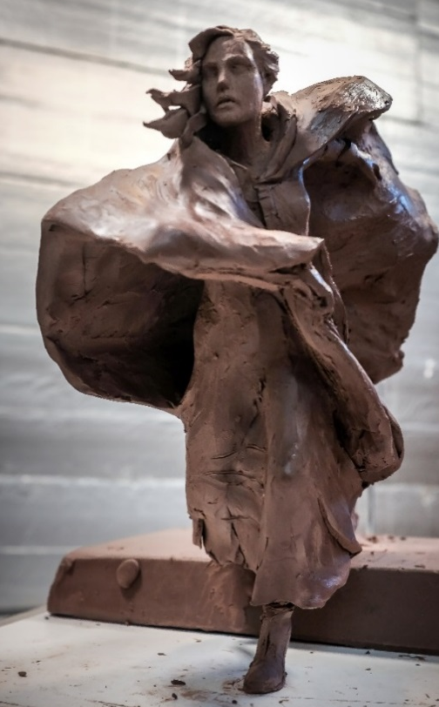
Mr. Davies made a mtion provide a grant $1,000 to the City of Travelers Rest for their “Dicey” Langston sculpture project.
Mr. Collins seconded the motion. There was no discussion. All approved.

Mr. Davies made a motion that the Commission award grants of $3,000 to any South Carolina county forming, organizing, and staffing a Committee of 99 to plan local Revolutionary War educational programs, 250th celebrations, and cultural heritage tourism infrastructure. Mrs. Culbertson seconded the motion. There was no discussion. All approve.

SC Chamber of Commerce –Mr. Baxley recently had a very productive meeting with Bob Morgan, SC Chamber of Commerce President & CEO. Mr. Baxley spoke via Zoom to their executive committee. Mr. Morgan is supportive of the Commission’s purpose and invited Mr. Baxley back to speak again.

Meeting with SC Department of Transportation – Mr. Baxley met with Leland D. Colvin, PE, Deputy Secretary for Engineering at SC DOT and their Director of Environmental Services (archaeologist) Chad Long concerning several SC 250th projects:
    - Developing an interpretative pull off at Sampit River Bridge – Gen. Francis Marion battlefield in Georgetown County
    - Developing sample pull off sketches for safety and viewing Revolutionary sites which will not become parks – building safe tourism infrastructure (See attachment 6)
    - Specially marking SC’s colonial highways which are still in use today
This was a great meeting and Mr. Baxley received positive responses in the discussions of the topics show above. SC-DOT provides 50% of the funding for the Arch-site map staff person. Mr. Baxley said a sketchbook demonstrating how to create successful pull-offs is needed to assist local areas in their historic pull-off site development. There was a brief discussion on various signage used in South Carolina and other states to identify colonial roadways.

Liberty Live’s American Revolution educational programs –Re-enactors Dr. Tray Dunaway, Tom Oblak, and Shari Davis gave brief samples of the presentations.

Mrs. Foster will be coordinating volunteers to work in the SC 250th exhibits at four upcoming events. Battle of Camden education day and battle reenactment, the SC Archives and History Foundation American Revolution Symposium on December 4 and the program at Historic Camden on November 6, and the Francis Marion Symposium October 22-23 (exhibit 8).

South Carolina Battlefield Preservation Trust and SC Liberty Trail – Mr. Reuwer gave an update on the Liberty Trail’s electronic app, land acquisition, and the status of development on six new Revolutionary War parks: Waxhaws, Hanging Rock, Camden, Eutaw Springs, Fair Lawn Plantation, and Blackstock’s Plantation. Progress at these sites continues faster than anticipated. Each needs a “friends” group to assist with maintenance. The “digital” Liberty Trail is to receive $400,000 of state appropriations. Mr. Bostick added that the app is currently in test mode. The app will offer the ability to plan an itinerary. Mr. Reuwer said these locations should provide recreation, natural resources and history. Research sources are archival, antidotal and archaeological based. He recommended reading Building a Bridge to the 18th Century: How the Past Can Improve Our Future by Neil Postman.

US Semiquincentennial (250th) Commission and their America 250 Foundation –
Mr. Bennett reported on the latest US 250th plans. Charleston, SC is to be the site of a statutory “signature” event on July 4, 2026, five other SC towns and cities may be “Fourth on Main” sponsored events on July 4, 2026 and $10,000 grants maybe be available to support in state events.

SC Revolutionary Era approved Roadside Historical Markers inventory - Mrs. Foster reported that Bill Segars and his team has done an amazing amount of work on collecting information on these markers– see attachment 7. She and Mr. Segars have begun discussion on the best method to get this information to the marker sponsors.
Summary to date:
a. Inventory – 163 SCDAH markers visited, GPSed, and photographed; 19 MIA; many need maintenance
        - Inventory expanded to other Revolutionary Era markers, private, and non-SC DAH approved
        - Starting on locating and talking with sponsors of MIA, wounded, and orphaned markers
        - A map and information about all Revolutionary Era approved markers is on the Commission’s new website

Revolutionary War Visitors Center in Camden – Mr. Carpenter gave an update on the construction of the new Revolutionary War Visitors Center in Camden. Rickie Good is the new director. The visitors’ center is a separate facility from the Historic Camden facilities.

SC 250th Car tag – Mrs. Chewning reported that the first 100 numbered tags are available for Commissioners, Committee members, etc. She will get the information on placing an order. Tags will cost the usual tag rate plus a vanity tag fee. Mr. Baxley thanked Mr. Baker for all of his efforts in making this happen in a short amount of time.
SC motor vehicle license plate law – SC Act No. 11, see Attachment 5
https://www.scstatehouse.gov/sess124_2021-2022/bills/3501.htm

Doug Bostick reported on US Bill H.R. 1286 to establish in the States of North Carolina and South Carolina the Southern Campaign of the Revolution National Heritage Corridor. Senator Clyburn filed the bill for the Southern Campaign of the Revolution National Heritage Corridor and recruited the other Congressional Delegates from SC to sign on as sponsors. Mr. Bostick testified at the hearing. Senators Graham and Scott have promised to sponsor the companion legislation in the U.S. Senate.

The next regular Commission meeting is scheduled for Wednesday, October 20, 2021 at 10:00 am in person (unless Covid-19 variant cases have substantially increased) and is to be held at Charles Town Landing State Park if space is available. Mr. Davies also requested follow up with Commissioners who have not been regularly attending meetings. Mr. Davies made a motion to hold the next meeting at Charles Town Landing State Park. Mr. Bennett seconded the motion. All agreed. Mr. Marshall volunteered to arrange for lunch.

Concern of a loss of time and momentum due to Covid – do we need to plan another retreat? This discussion will continue at the next meeting.

Mr. Baxley said we have an offer to do a morning regular meeting and tour a Revolutionary War battlefield in the afternoon. The consensus was that is a good idea. Mrs. Cazel said there was adequate meeting space the Cherokee Historical and Preservation Society. We could have a morning meeting and tour one of the area battle sites in the afternoon.

There was no further business.

Mr. Davies made a motion to adjourn. Mr. Bennett seconded the motion. All agreed.

The meeting adjourned at 2:50 pm.

Attachment 1

Diana Bramble Named Superintendent of Cowpens National Battlefield and

Kings Mountain National Military Park

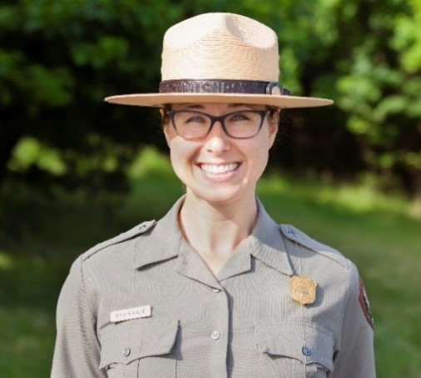
News Release Date: February 10, 2021 (NPS Photo)
ATLANTA — Today, National Park Service (NPS) South Atlantic-Gulf Regional Director Stan Austin announced the selection of Diana Bramble as the new superintendent of South Carolina’s Cowpens National Battlefield and Kings Mountain National Military Park, effective March 14. In her role, Bramble will also oversee management of Overmountain Victory National Historic Trail and Ninety Six National Historic Site. Bramble has managed the four units on temporary assignment since September.
“Diana brings experience caring for iconic landmarks with complex operations and stories critical to America’s advancement as a democratic society,” Austin said. “As we prepare to mark the 250th anniversary of the American Revolution, Diana is wholly committed to protecting the parks’ treasured resources and enhancing collaboration with staff, visitors, partners and gateway communities.”
Bramble said, “I am incredibly grateful to have been selected for this opportunity. The staff here are profoundly dedicated to their work as caretakers of America’s heritage. It is an honor to help lead the park as a team towards an exciting future with many opportunities for partnership and engagement in anticipation of the 250th commemoration of America’s founding.”
Bramble began her NPS career in 2011 as the supervisory horticulturist for Rock Creek Park in Washington, D.C. with responsibility for horticulture, arboriculture and grounds management. Four years later, she became chief of maintenance at National Capital Parks-East, where she has managed the entire facility operations and project management portfolio for a vast set of resources spanning 8,000 acres, including historic homes, commuter parkways, earthen and masonry fortifications, working farms, marinas and a campground. Prior to joining NPS, Bramble worked six years at the Smithsonian Institution as a horticulturist.
Originally from the Eastern Shore of Maryland, Bramble holds a Bachelor of Science degree in natural resources from University of Maryland and a Master of Professional Studies in sustainable landscape design from George Washington University. She is a graduate of the NPS Facility Manager Leaders Program and now serves as a program mentor. In 2019, Bramble was awarded the NPS National Capital Area Facility Manager of the Year honor.
Outside of work, Bramble enjoys spoiling her niece and nephews, spending time outdoors, traveling and strength training.
https://www.nps.gov/cowp/learn/news/2-10-21-supt-annct.htm
Attachment 2
FY 2021-2022 budget as approved by this Commission

Critical Task |  | Approved Budget
Communications
 | Printed materials | $ 12,000.00
 | Website development & URLs | $ 6,000.00
 | Telephones & computer system, software | $ 6,000.00
 | Public media support | $ 24,000.00
 | Postage & shipping | $ 3,000.00
 | Quarterly newsletters to stakeholders | $ 6,000.00
 | Development of communications database | $ 8,000.00
Administration
 | Executive | $ 125,000.00
 | AA | $ 60,000.00
 | Admin. Tourism Conferences | $ 4,000.00
 | Administrative Travel | $ 9,000.00
 | Office rents | $ 18,000.00
 | Office furniture & equipment rents | $ 10,000.00
Branding
 | Graphics artist | $ 9,000.00
 | TM registrations | $ 2,000.00
Commissioners
 | Travel | $ 15,000.00
 | National and Regional Meetings | $ 16,000.00
Support of Site (Product) Development
 | RW Site Acquisition & Pull Off Development | $ 450,000.00
 | Site Development & Interpretation | $ 100,000.00
 | Marketing | $ 25,000.00
 | Operations & Maintenance | $ 20,000.00
Support of SC Rev. War Research |  | $ 80,000.00
 | Thomas Sumter papers
 | Francis Marion papers
 | John Rutledge papers
 | SC Militia Officers
 | SC Loyalist Claims
 | SC Battle Maps
 | Site archaeology
Support of Publications |  | $ 60,000.00
 | Battlefield Guides
 | American Leadership Biographies
 | Impacts on Loyalists
 | Impacts on Native Americans
 | Impacts on enslaved peoples
 | Publication access via Internet
Development and operations of speakers bureau |  | $ 15,000.00
Support of SC Rev. War Conferences and Symposia |  | $ 10,000.00
Museum and Visitors Center Rev. War boards |  | $ 60,000.00
 | Offer a package of a site tour board
 | and a local Revolutionary War action board
Support of K-12 School Curriculum & Materials |  | $ 80,000.00
 | School SC Rev. War posters
 | SCETV school projects
Development of Local 250th Commissions |  | $ 140,000.00
 | Outreach & communications
 | Local project grants
Promotion of local commemorative activities |  | $ 20,000.00
 | public art, performances, living history
Identification & Marking SC Colonial Roads |  | $ 15,000.00
New Roadside Historic markers & maintenance |  | $ 38,000.00
 | Total Budget Request | $ 1,446,000.00

Attachment 3
FY 2021-2022 budget as approved by The South Carolina General Assembly

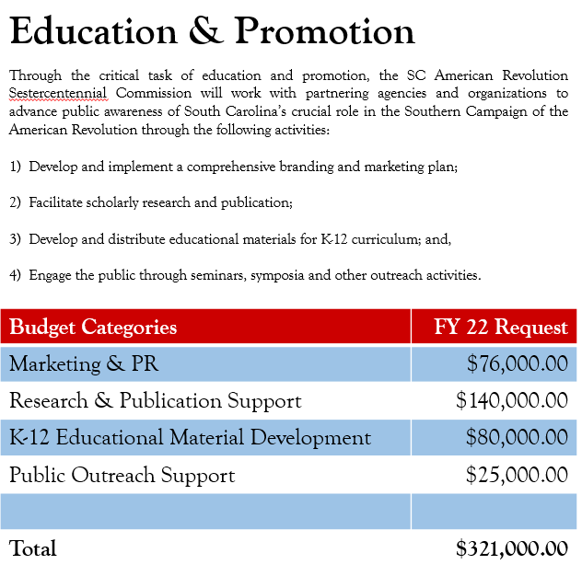
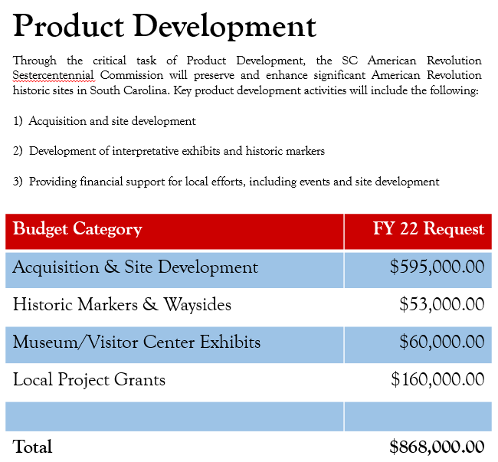
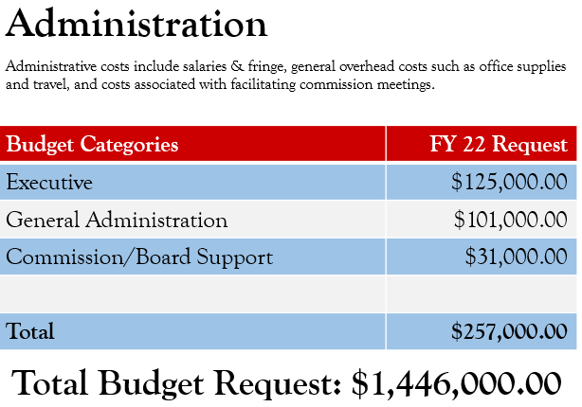

Attachment 4
SC 250th Commission Committee Assignments [as of July 18, 2021]
Charles B. Baxley – Chairman
Bill Davies – Vice Chairman
Dianne Culbertson – Chaplain
Duane Parrish – (Director SC PRT) statutory Executive Secretary
Dr. A.V. Huff – (Chair, SC A&H Board) statutory Assistant Executive Secretary
Donna Foster – (SC A&H Foundation) acting secretary; advisors Dr. Eric Emerson (Director SC Dept. A&H) and Doug Bostick (President SC BPT)

Standing Committees

Education Committee – Sen. Floyd Nicholson – Chairman; Neal Collins; Zach Lemhouse; Justin Lovelace; Kevin Kerr; and Jannie Harriot
Partnerships Committee – Emily deQuincey-Newman – Chairperson; Dianne Culbertson
Budget and Finance Committee – Vic Carpenter, Chairman; Pam Cazal; Brett Bennett; Laurie S. Funderburk; and Steve Moss
Marketing, Branding, and Public Relations Committee – Pam Melton Cazel – Chairperson; Laurie Funderburk; Duane Parrish; Dolly Chewning; Perry Baker; and Jannie Harriot
Publications Committee – Charles Baxley, acting chair; Dr. Eric Emerson; Dr. Dan Tortora; Zach Lemhouse; Brett Bennett; Guy Wallace; Jannie Harriot; Prof. Larry Watson; Dr. Fritz Hamer; and Prof. Larry Rowland
Performance Evaluation (Metrics) – Laurie S. Funderburk – Chair; Tom Oblak
Ad Hoc Committees
Speakers Bureau – Dr. Tray Dunaway, Director; Bill Davies, acting chair; Jannie Harriot and Donna Foster
Historical Markers Survey – Bill Segars, chair; Dr. Fritz Hamer; Bill Marshall, Guy Wallace
Website Development and Operations – Vic Carpenter, Charles Baxley, Perry Baker
Museum Local Revolutionary Era Display Boards – Charles Baxley, Doug Bostick, Donna Foster
Morris Center for Lowcountry Heritage Museum Local Revolutionary Era Display Boards project – Bill Davies with project co-directors Isaac Bennett and Joe Riddle: Jami Boone, project graphics artist; Bill Davies, Donna Foster, Tamara Herring, Executive Director, Morris Center and Kayleigh Vaughn, Director of Exhibitions and Programs of the Morris Center; Dr. Larry Rowland, Cheryl Oliver, Joan Rountree, Heather Hodges, Doug Bostick, and Bill Whitten
Darlington County Museum Local Revolutionary Era Display Board project – Bill Segars, Brian Gandy, Charles Baxley
Relationship Manager – SC Humanities – Laurie S. Funderburk
US 250th Commission and Foundation – Brett Bennett
SC Revolutionary Era Timeline – referenced David P. Reuwer Chair, Guy Wallace, Guy Higgins
SC Revolutionary Era Bibliography – Brett Bennett, Chair, Elaine Rohr, SC Archives,
Administrative database – Donna Foster
Key Advisors and Volunteers
J. Brett Bennett, businessman; Perry Baker and Dolly Chewning, SCPRT media; Zach Lemhouse, historian; Diane Bramble, NPS; Douglas W. Bostick, SCBPT, historian and preservationist; David P. Reuwer, Esq. historian and SCPBT officer; W. Eric Emerson, PhD, Director, SC Dept. of Archives & History; Guy Wallace; Dr. Dan Tortora, teacher, author, historian; History Profs. Larry Watson, Jeff Dennis, Larry Rowland, and Able Bartley; historians Todd Braisted, Rick Wise, and Dr. Fritz Hamer; Bill Segars, general contractor, photographer and historian; Dr. Ken Lewis, archaeologist; and Eric Barnes, pod-casts.

Attachment 5

Specialty SC Automobile License Plates
(R17, H3501)
AN ACT TO AMEND THE CODE OF LAWS OF SOUTH CAROLINA, 1976, BY ADDING ARTICLE 148 TO CHAPTER 3, TITLE 56 SO AS TO PROVIDE THE DEPARTMENT OF MOTOR VEHICLES MAY ISSUE TWO HUNDRED FIFTY YEAR ANNIVERSARY REVOLUTIONARY WAR COMMEMORATIVE SPECIAL LICENSE PLATES.
Be it enacted by the General Assembly of the State of South Carolina:
Special license plates
SECTION 1. Chapter 3, Title 56 of the 1976 Code is amended by adding:
“Article 148
Two Hundred Fifty Year Anniversary Revolutionary War
Special Commemorative Special License Plates
Section 56-3-14810. (A) The Department of Motor Vehicles may issue special commemorative motor vehicle license plates commemorating the two hundred fiftieth anniversary of the American Revolution to owners of private passenger carrying motor vehicles or motorcycles registered in their names. The biennial fee for this commemorative license plate is the same as the fee provided in Article 5, Chapter 3 of this title.
(B) The South Carolina Revolutionary War Sestercentennial Commission shall submit to the department for approval the design, emblem, seal, logo, or other symbols it desires to be used for this special license plate.
(C) This special license plate is exempt from the provisions contained in Section 56-3-8100.
(D) The production of this special license plate will cease January 1, 2033.”
SC Automobile specialty license tag – SCDMV and our project coordinator, Perry Baker of SCPRT
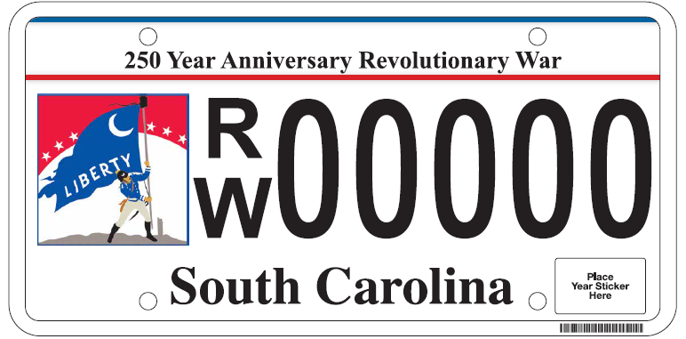
    - Artwork courtesy of SCPRT (thanks Duane) and Pam Cazal

    - The cost to the consumer to purchase the plate is $35 correct? Perry: The fee is the regular registration fee $40 for cars and trucks based on Gross Vehicle Weight.
    - At what point will the new plate be available to the general public for purchase? Perry: The plate will be available January 1, 2022 and will cease production January 1, 2023.
    - How does the Commission assign or designate the low number plates (first 100 plates that were set aside). Is there a form they would fill out and submit? At what point can those designated numbers be requested? Does the numbering start with 0000 or 0001? Perry: The reserved range will be 1-100. The Authorized Agent will be provided a spreadsheet to make plate number assignments. Applications for reserved numbers must be processed by mail at the DMV HQ. Applicants will use the attached Reserved Application. Note: She didn’t attach the Reserved Application in her email, so I will follow up with that. Perry
    - What is the process for the money from plate purchases to get from DMV to the Commission? And is that amount per plate the entire $35 or just a portion? Perry: The legislation authorizing the plate does not require an additional specialty fee or allocate funds to the commission from SCDMV.

Attachment 6
SC American Revolutionary 250th Commission pull off development and interpretation projects
To help South Carolina get ready for the 250th Anniversary cultural heritage tourism SC 250th anticipates we will seek to sponsor joint ventures (with DOT, counties, cities, etc. to leverage our funds) of couple of prototype site pull offs to work out idealized design parameters and interpretation plans. Some sites deserve serval pull offs, like Burdell’s Plantation to Eutaw Springs, and others can be one and done sites. Having them geographically dispersed helps with the politics, and picking the proverbial low hanging fruit helps with partnership development.
Developing interpretative pull offs would to enhance the SC Liberty Trail at sites where there are no existing parks, interpretation, and none planned.
Here is a potential highway pull off site list (sites in no particular order)
- Thomson/Belleville/Ft. Motte/Big Glade (?) [(?) indicates sites not precisely located]
- Fish Dam Ford [state agencies already own the property]
- Hammond’s Old Store (?)
- Avenue of the Cedars
- Black Mingo
- Blue Savannah
- Stono Ferry
- Shubrick’s Plantation
- Cary’s Fort (?)
- Coosawhatchie
- Tearcoat Swamp (?)
- Mt. Hope Swamp
- Eutaw Springs
- Earle’s Ford
- Rugeley’s Mill/Claremont and Rugeley’s Barn
- Hayes’ Station [not on a highway]
- Sumter’s Nelson’s Ferry Home and Great Savannah (?)
- Beattie’s Mill (?)
- Long Canes (?)
- Great Cane Break (?)
- Actual Musgrove Mill
- Tar Bluff [not on a highway]
- James Williams’ Fort (?) [not on a highway]
- Sampit River Bridge
- Andrew Pickens’ Ring Fight (?)
- Andrew Williamson’s home and fort (?)
- Rocky Mount
- Alexander’s Old Field (Beckhamville)
- Mobley’s Meeting House
- Wofford’s Iron Works
- Hill’s iron Works

- Special sites which need an especial delicate touch: Biggin Church ruins, Mepkin, Francis Marion’s, Thomas Sumter’s, Andrew Pickens’, and Isaac Hayne’s graves
- Some existing parking lots and pull offs that just need stepped up interpretation: Wadboo Bridge, Lower Bridge, Wide Awake Plantation (Stono), Saltcatcher (Patterson’s) Bridge, Ft. Thicketty (Ft. Anderson), Dunham’s Bluff/Snow’s Island, Quinby Bridge, Purrysburg, Ft. Galphin (Ft. Dreadnaught)
- Another list of sites for a simple roadside historical marker (another good joint venture opportunity: Martintown, Grindal Shoals, Wiggins Hill (?), several Mt. Pleasant sites (SC Navy shipyard, batteries, barracks/prison, powder magazine) ...

We will discuss with SC DOT some general pull off design parameters, physical size, safety, drainage, etc. and how you would like to structure our relationships with partners, if any, on this project.
Initial staff work should include general land, parking size and access requirements, turn radius, sight line considerations, and costs estimates. Identification of sources of potential funding for land acquisition, engineering, and on-site interpretation should also be examined. A pull off plan book would be useful.
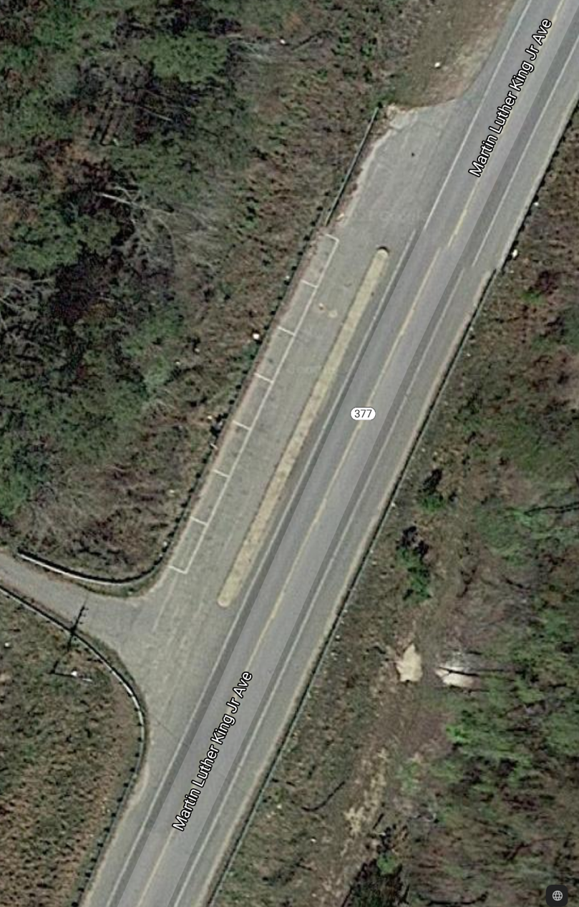
A good example is the pull off on SC Hwy 377 (Martin Luther King, Jr. Avenue) just below Lower Bridge (Black River), near Salters, SC. This pull off is fairly simple, will accommodate two buses or 10 automobiles, and is accessible either way of travel, but was fairly expensive since it is on an elevated causeway.

States have been building pull offs for scenic sites for years.

Attachment 7

American Revolution Historical Markers Inventory Project
7/19/21
What started in April of 2020 to find 185 SCDAH American Revolutionary Roadside Historical markers has now grown to 231 roadside markers. Additionally, in an effort to draw more attention to other American Revolutionary sites and monuments in South Carolina, 235 more sites have been added to this project, for a total of 466 sites. We feel that these monuments or sites are valuable in showing the important part that South Carolina played in winning the American Revolution. One of our main goals through this inventory project is to make the location of these sites available to locals and the many visitors that are expected to come to South Carolina.
To date, with a team of volunteers we have found, photographed and researched 339 of these 466 sites. Hopefully by the first part of 2022, we will complete this list. Even with an incomplete list we have moved into other areas of what to do with the collected information. We realize that collected information is no better than how that information is disseminated.
We are currently working on two ways to put this information to work:
- Guy Wallace is working with Caroline Chambers in putting these historical sites on a Goggle Mapping program that can be interacted with the South Carolina American Revolution Sestercentennial Commission’s website when it becomes open to the public. With one of the main reasons for finding these sites being collecting exact GPS coordinates, the best way to pass this information on is with a map. Addition information to be included on this map will be related websites and photographs of each site that should peak a potential visitor’s interest to travel to these historical locations.

- Donna Foster is beginning to work with our “problem SCDAH markers”. All of the found markers have been graded as to their appearance condition. If we are going to encourage visitors to come see our Roadside Historical Markers, they need to be in place and they need to be in good condition. Unfortunately we have 26 missing markers and many that are in substandard condition, or at least in a condition that we’re not real proud of. Donna’s main focus will be to contact sponsoring agencies to encourage repairing or replacing their “problem markers”. If that contact proves to be non productive, then a list of “orphan markers” will be presented to the Commission for future discussion.
If you have any comments or questions concerning the Historical Markers Inventory Project or to supply us with information concerning historical sites in your area feel free to contact Bill Segars at billsegars@gmail.com, we’re all in this together.

Attachment 8

Need SC 250th Anniversary Booth Presence and Volunteer Manning

Need volunteers
        - 19th Francis Marion Symposium, Manning, SC - Oct. 22-23 https://clarendonmurals.com/symposium
        - Rev. War Visitors Center at Camden - Nov. 6 morning program SC A&H Foundation program – (presenters Eric Emerson and Bill Davies) - Donna Foster lined up program
        - Hobkirk Hill Reenactment (10 miles NE of Camden) - Nov. 12-13-14, 2021 - Donna lining up booth manning
https://www.continentalline.org/CL/wp-content/uploads/Event_Info/2021/Battle-of-Hobkirks-Hill-Camden-2021.pdf
        - SC A&H Foundation Annual Revolutionary War Symposium in Columbia - Dec. 4, Donna lining up program https://scarchivesandhistoryfoundation.org/wp-content/uploads/2021/06/BrochureARS2021.pdf

Probably joint venture table with SC Battleground Preservation Trust, The SC Liberty Trail, and the Southern Revolutionary War Institute

