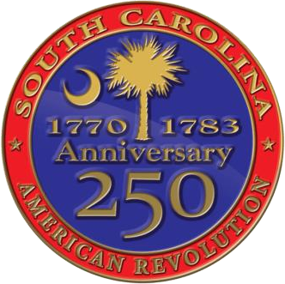
South Carolina American Revolution Sestercentennial Commission

Executive Committee Meeting (In-Person with Webex Available)
Friday, October 28, 2022, at 10:30 A.M.
SC Department of Archives & History 8301 Parklane Rd Columbia, SC 29223
Meeting link: https://scamericanrevolutionsestercentennialcommission.my.webex.com/scamericanrevolutionse stercentennialcommission.my/j.php?MTID=mca08abe0087e2a5c44a94449b72184fb
Meeting number: 2634 673 7330
Meeting password: p64kZes2fum
Join by phone: +1-650-479-3208 United States Toll Access code: 26346737330
Contact Heather Hawkins 803-898-3392 to join by other methods.

Proposed Agenda
10:00 AM - A few moments of reflection and perspective with Chaplain Dianne Culbertson

- Call to Order and Introductions - Chairman Mr. Baxley

- Declaration of Quorum – Vice-Chair Mr. Davies

- Confirmation the Notice of Meeting and Proposed Agenda has been posted in Compliance with FOIA - Recording Sec. Ms. Hawkins

- Adoption of Proposed Agenda - Chairman Mr. Baxley

- Approval of Consent Agenda Items:
  - Attachment A - Approval of Minutes from July 28, 2022 Meeting - Mr. Davies

- Public Comments (if any)

- Site Development Projects – Mr. Baxley

- Standing Committee Updates
  - Budget & Finance
    - Attachment B – 23FY Budget v Actual

  - Marketing, Branding, & Public Relations Committee
  - Education Committee
    - Attachment C – Patriot Express Education Bus
  - Publication & Research Committee
  - Partnership Committee
    - Motion to approve Doug MacIntyre as the Historic Charleston & Resort Islands Volunteer Regional Coordinator
  - Performance Evaluation (Metrics)

- SC250 Grant Programs Update – Ms. Hawkins
  - Motion to extend Local Activities Grant application budget cap to $20,000

- Update from Statutory Partner – Doug Bostick, CEO of the SCBPT

- Administrative Updates
  - Executive Director’s Update – Ms. Fortune
  - Chairman’s Update – Mr. Baxley

- Upcoming Meetings
  - Full Commission Meeting Tuesday, November 29, 2022 at 10:00a at Hopsewee Plantation / Tours + Local Meet & Greet on November 28
  - Motion to approve location - Full Commission Meeting Friday, February 24, 2023 at 10:00a at Living History Park in North Augusta
  - Full Commission Meeting Friday, May 19, 2023 at 10:00a / Location Suggestions?
Noon - Adjournment Attachments:
Attachment A – July 28, 2022 Exec Committee Meeting Minutes
Attachment B – 23FY Budget v Actual as of 10/20/22 Attachment C – American Revolution Education Bus

