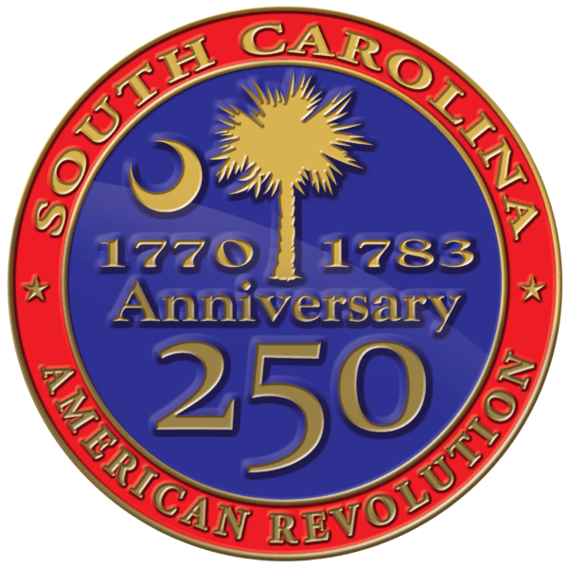
South Carolina American Revolution
Sestercentennial Commission

Full Commission Meeting
Tuesday, November 29, 2022, at 10:00 A.M.
Hopsewee Plantation 494 Hopsewee Rd., Georgetown, SC 29440
(Birthplace of Thomas Lynch, Jr., one of South Carolina’s signers of the Declaration of Independence)

Meeting link: https://scamericanrevolutionsestercentennialcommission.my.webex.com/scamericanrevolutionsestercentennialcommission.my/j.php?MTID=md12dbb2f7a34ca49c40898a6e8364a54
Meeting number: 2634 181 4233 Meeting password: PSxxf2dAZ73
Join by phone +1-650-479-3208 United States Toll Access code: 26341814233
Contact Heather Hawkins 803-898-3392 to join by other methods.

SC250 Commission members have all been invited to Guided Tours of Georgetown’s Downtown Museums starting on Monday, November 28, 2022 at 2:45 P.M. (Meeting at Rice Museum’s tower 633 Front St. Georgetown, SC 29440) and a Pre-Meeting Meet & Greet Reception at 6:00 P.M. (Georgetown County Museum 120 Broad St. Georgetown, SC 29440). They have also been invited to a Gullah Geechee presentation and tour of Hopsewee following the formal meeting on November 29. For more information, contact Coordinator Heather Hawkins at 803-898-3392.
Proposed Agenda
10:00 AM - A few moments in memory of the late Commissioner Emily deQuincey-Newman with Chaplain Dianne Culbertson
- Welcoming Remarks from hosts: Raejean Beattie (Hopsewee Plantation), Muff Boyd (Georgetown County Museum), Mark Stevens (Georgetown County Chamber)

- Call to Order and Introductions - Chairman Mr. Baxley

- Declaration of Quorum – Vice-Chair Mr. Davies

- Confirmation the Notice of Meeting and Proposed Agenda has been posted in Compliance with FOIA - Recording Sec. Ms. Hawkins

- Adoption of Proposed Agenda - Chairman Mr. Baxley

- Public Comments

- Approval of Consent Agenda Items:
  - Approval of Minutes from September 28, 2022 Meeting - Vice Chair Mr. Davies (Attachment A)

- Staffing – Ms. Fortune
  - Welcome Mike Tyler
  - Regional Coordinators (Volunteers)
    - Lowcountry Coordinator – Doug MacIntyre

- Site Development Projects – Mr. Baxley

- Committee Updates
  - Budget & Finance – Mr. Bennett
    - 23FY Budget vs. Actual as of 11-16-22 (Attachment B)
    - 24FY Budget State Budget Request
    - Starting a Foundation & Trust – Ms. Fortune

  - Marketing, Branding, & Public Relations – Ms. Pam Cazel
    - Update on Ad Agency RFP – Ms. Fortune

  - Education Committee – Rep. Neal Collins
    - Update on HistoryMan Comic Books – Ms. Hawkins
    - Great Feedback from SC Society for the Social Studies & Colonial Charleston Teacher Professional Development Class / Interest in Teacher Ambassador Program – Ms. Hawkins / Mr. Bennett
    - Next Meeting TBD

  - Publication & Research Committee – Mr. Baxley
    - Heroines
    - Military Leaders
    - Battles & Skirmishes
    - Battlefield Guides
    - Update: Gen. Francis Marion Papers Project – Rick Wise, Managing Editor
    - Update: Gen. Thomas Sumter Wartime Papers: Zach Lemhouse, Editor
    - Update: Col. Francis, Lord Rawdon (Hastings) Wartime Papers project: Todd Braisted, Editor
    - Update: SC 3rd Regimental History – Zach Lemhouse, author
    - Update: digital publication of Dr. Bobby Gilmer Moss’ dissertation: The roles of the Scots and Scotch-Irishmen in the Southern Campaigns in the War of American Independence 1780-1783.

  - Partnership Committee
    - Ratify Chairman’s Appointment of Dianne Culbertson as the New Chairperson of the Partnership Committee.
    - County 250 Committee Update – Mr. Davies

- SC250 Grant Programs Update – Ms. Hawkins
  - 22FY Grantees
    - Status Reports (Attachment C)
  - 23FYQ2 Competitive Grants
    - Updated Grant Programs Basics Page (Attachment D)
    - Motion to transfer remaining funds in the 23FYQ1 Safety Grant for Southern Campaign 1780 from Battle of Camden Reenactment to crowd management & parking for Reinternment of Battle of Camden Soldiers in April 2023.
    - 23FYQ2 Grant Applications
      - Staff Reviewed – A motion to approve:
        - Museum Panel Grants
          - $4,800 to City of Camden for Outdoor Cavalry & Catawba Panels at Revolutionary War Visitors Center
        - Publication Grants
          - $28,300 to Lake Hartwell Country (Multi-County) American Revolution Website & Assets
          - $6,000 to SC Battleground Preservation Trust for research and writing text for the Siege of Charleston Battlefield Guide (Battlefield Guide project funding approved at last meeting)
        - County Asset Assessment & Historic Tourism Plan Grants
          - $7,500 to Cherokee County (on behalf of Cherokee County 250) for county asset and tourism plan
        - Research Grants
          - $6,000 to SC Battleground Preservation Trust for transcription of Loyalist Claims – Phase 1 (Volume 26)
        - Local Activities Grant
          - $5,450 to Laurens District Chapter of the SC Genealogical Society to support the state annual meeting in 2023, which the group is hosting
        - Education Grants
          - $9,999 to Cherokee County (on behalf of Cherokee County 250 Committee) for Education Interactive Event
          - $10,000 to Florence County (on behalf of Florence County Museum) Snow’s Island: Frontier of Prose and Lore Exhibition
        - Site Grant: Development
          - $5,495 to Berkeley County Museum for Fort Fair Lawn Docent Training Program
          - $41,760 to Cultural & Heritage Museums of York County for Brattonsville Watt Site
          - $70,000 to SC Battleground Preservation Trust for the acquisition and due diligence at Alexander’s Old Field (Chester Co.)
          - $124,000 to SC Battleground Preservation Trust for acquisition of Bradham Property / Eutaw Springs Battlefield (Orangeburg Co.)
      - Grant Requests Currently Under Review
        - Publication Grant
          - $17,000 to Cheritawba Games LLC (Bryan Collars) for Crown & Crescent: Struggle for Independence in SC – American Revolution Strategy Game
        - Research Grant
          - $15,000 to Dr. Larry Watson (Watson Research Enterprise) for research on The Impact of the American Revolution on Slave Manumissions in South Carolina,1760-1800
          - $20,000 to Cherokee County (on behalf of the Cherokee County 250 Committee) for Ft. Thicketty Research Project - gathering documents related to Ft. Thicketty and begin to frame interpretation of the site
        - Local Activities Grant
          - $4,750 to SC Confederate Relic Room & Military Museum for Revolutionary War Day 2023
          - $24,681 to Southern Campaign of 1780 for Statewide, Long-Term Event & Educational Items for Improved Demonstration Capabilities
          - $8,000 to Long Gone LLC (Margaret Buckelew) for Marketing & Website updates for Revolutionary War Tours (Kershaw County)
          - $10,000 to Long Gone LLC (Margaret Buckelew) for Revolutionary War Week events (Kershaw County)
          - $8,000 for the Revolutionary War Museum & Library, Inc. (Tom Weidner) for Revolutionary War Firearms display
        - Signage & Marker Grants
          - $9,599 to Cherokee County (on behalf of Cherokee County 250 Committee) for Cherokee County’s Liberty Trail Connections – marking driving tour of Cherokee County’s American Revolution assets
        - Education Grants
          - $10,000 to Long Gone LLC (Margaret Buckelew) for reboot of History Club for Kids (Kershaw Co.)
  - 23FYQ3 Deadline February 9, 2022 at 3:00 P.M.
    - Getting the word out about the opportunities
    - How To Apply Webinar Scheduled for January 10 at 1:00 P.M.
    - A Motion to approve an Updated Review Process starting with 23FYQ3 (Attachment E)

- Update from Statutory Partners

- Administrative Updates
  - Executive Director’s Update – Ms. Fortune

  - Chairman’s Update – Mr. Baxley

  - Next Full Commission Meeting: Friday, February 24, 2023 at 10:00 A.M. Living History Park 299 W. Spring Grove Avenue, North Augusta, South Carolina 29841 – Pre-Meeting events planned for Thursday, February 23, 2023 – more details to come

Noon - Adjournment

Attachments:
Attachment A – September 28, 2022 Full Commission Meeting Minutes
Attachment B – 23FY Budget v Actual as of 11/15/22
Attachment C – 22FY Grants Status Report
Attachment D – 23FY Grant Basics Updated
Attachment E – Updated Grant Review Process to Start 23FYQ3

