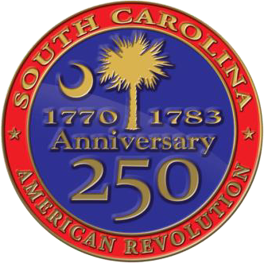
South Carolina American Revolution Sestercentennial Commission

Virtual Executive Committee Meeting Tuesday, January 17, 2023, at 10:00 A.M.
Meeting link: https://scamericanrevolutionsestercentennialcommission.my.webex.com/scamericanrevoluti onsestercentennialcommission.my/j.php?MTID=m212237d819fdf0436df6eb0f084d53d5
Meeting number: 2634 253 6642
Meeting password:3wcP9H3RAKE
Join by phone +1-650-479-3208 United States Toll Access code: 26342536642
Contact Heather Hawkins at 803-898-3392 with any questions.

Proposed Agenda
10:00 AM - A few moments of reflection and perspective with Chaplain Dianne Culbertson

- Call to Order and Introductions - Chairman Mr. Baxley

- Declaration of Quorum – Vice-Chair Mr. Davies

- Confirmation the Notice of Meeting and Proposed Agenda has been posted in Compliance with FOIA - Recording Sec. Ms. Hawkins

- Adoption of Proposed Agenda - Chairman Mr. Baxley

- Approval of Consent Agenda Items:
  - Approval of Minutes from October 28, 2022 Meeting - (Attachment A)

- Public Comments (if any)

- Committee Updates
  - Budget & Finance
    - 2023-2024 FY Budget Ask and strategy
    - 2023-2024 FY Executive Budget
    - 2023-2024 FY Budget Update

- SC250 Grant Programs Update – Ms. Hawkins
  - A Motion to approve 23FYQ2 Additional Grants – Ms. Fortune
    - Research Grants
      - $15,000 to Dr. Larry Watson (Watson Research Enterprise) for research on The Impact of the American Revolution on Slave Manumissions in South Carolina, 1760-1800
    - Local Activities Grant
      - $4,750 to SC Confederate Relic Room & Military Museum for Revolutionary War Day 2023
      - $8,000 to Long Gone LLC (Margaret Buckelew) for Marketing & Website updates for Revolutionary War Tours (Kershaw County)
      - $10,000 to Long Gone LLC (Margaret Buckelew) for Revolutionary War Week events (Kershaw County)
      - $5,000 for the Revolutionary War Museum & Library, Inc. (Tom Weidner) for Revolutionary War Firearms display
    - Signage & Marker Grants
      - $9,599 to Cherokee County (on behalf of Cherokee County 250 Committee) for Cherokee County’s Liberty Trail Connections – marking driving tour of Cherokee County’s American Revolution assets
    - Education Grants
      - $10,000 to Long Gone LLC (Margaret Buckelew) for reboot of History Club for Kids (Kershaw Co.)

  - A Motion to Update Grant Policies for Site Acquisition Grants
    - Changing Delivery of Funds to 100% Upon Receipt of Initial Acquisition Documents – to pay for due diligence and closing funds available
      - 20% immediately to Grantee for due diligence and overhead; 80% in time for closing, to be held in trust by Grantee’s closing attorney.
    - Allowing for State Funds to be used for Required Match
    - Changing Executive Director’s Grant Amount Award Discretion
- Adjournment Attachments:
Attachment A – October 28, 2022 Executive Committee Meeting Minutes

