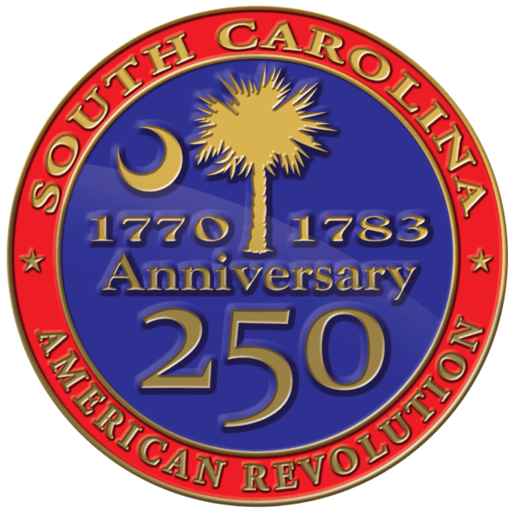
South Carolina American Revolution
Sestercentennial Commission
Executive Meeting
Monday, July 10, 2023 at 2:00 P.M.
Webex | Columbia, SC
SC250 Commission members were invited to an Executive Meeting via Webex on Monday, July 10,2023. Following the business meeting.
Present Via Webex
Commissioners: Chairman Charles Baxley, Treasurer Brett Bennett, Vice Chairman Bill Davies, Chaplain Dianne Culbertson Advisors: Doug Bostic Staff: Executive Director Molly Fortune, Grants Manager Heather Hawkins, Site Development Manger Mike Tyler, and Coordinator Aimee M Hood.

Absent: Duane Parrish

Call to Order
Chairman Baxley called the meeting to order around 2:02 PM. Vice Chairman Bill Davies confirmed there was a quorum of the Commission. Grants Manager Heather Hawkins confirmed that the public Notice of Meeting and Agenda had been posted at SC Dept. Archives & History and online.

Approval of Agenda
Chairman Baxley asked to approve the proposed agenda. Motion by Bill Davies. Seconded by Dianne Culbertson and approved unanimously.

Public Comments
No one spoke during public comments.

Consent Agenda
Vice Chairman Bill Davies made the motion to approve the Minutes from March 3, 2023 Meeting. Dianne Culbertson seconded, and it passed unanimously.

Executive Session:
At 2:07 PM Vice Chairman Bill Davies made a motion to go into Executive Session and was seconded by Brett Bennett. Vice Chair Bill Davies made the motion come back out of executive session. Second by Treasure Brett Bennett. Unanimously approved. No action was taken.

Executive Director Update:

FY2022-2023 Q3 and Q4 Grant Applications: Deferred, Rejected, Approved, or for Ex Comm’s review and action.

Park at Crawford Mill $180,0000
Vice Chair Bill Davies made a motion to follow staff recommendation to deny this grant request. Seconded by Treasure Brett Bennett.

Over Mountain Victory Trail
Vice Chair Bill Davies made to go with staff recommendation to deny this project request. Second by Brett Bennett. Unanimously voted.

Fort Fairlawn
Vice Chair Brett Bennett made the motion to support the staff decision to table this project. Seconded by Bill Davies. Unanimously approved.

Grahams Historic Meeting House 1,925,000
Vice Chair Bill Davies made a motion to accept the staff decision to reject this project. Second by Treasure Brett Davies. Unanimously approved.

Need the name of this project
Vice Chair Bill Davies made a motion to support the staff’s decision to deny this project. Seconded by Dianne Culbertson. Unanimously approved.

Cowpens Battlefield $7500
Vice Chair Bill Davies made a motion to support the staff’s decision to deny this project. Seconded by Brett Bennett. Unanimously approved.

Need name of project
Vice Chair Bill Davies made a motion to support the staff’s decisions to table this project. Seconded by Dianne Culbertson. Unanimously approved.

Charleston Library Society $8,000
Vice Chair Bill Davies made a motion to support the staff’s decision to table this project. Seconded by Brett Bennett. Unanimously approved.

Committee Updates:

Budget & Finance
Treasurer Brett Bennett reported that 1.9 million dollars in rollover funds. Most of the focus should be on how to allocate the 5 million that has been granted to us from the state legislature. Define what is allocated for the new fiscal year.

Vice Chair Bill Davies recommends allocating less to site development. Vice Chair Charles Baxley would like to have an interim budget and full commission signing off on budget.

Treasure Brett Bennett made a motion approved the interim budget as prepared and submitted by the staff and Vice Chairman Bill Davies seconded. Unanimously approved.

Chairman Updates
Chairman Baxley 2 years out from main influx of cultural tourists in anticipation on the 2026 anniversary. We are on the countdown to get the counties ready with great stores visitable sites, and excellent hospitality. We are making great progress on our sites but we have a long way to go. Our challenge this year is to better document and share all of our projects and progress.

Adjournment
Brett made a motion to Mr. Bennett made a motion to adjourn around 3:45p. Seconded by Bill Davies. Unamously approved.

