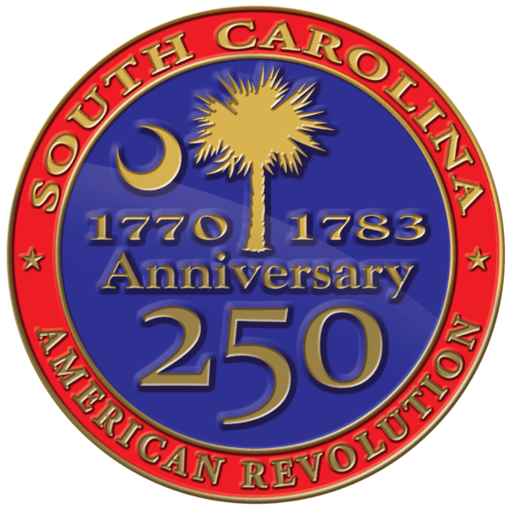
South Carolina American Revolution
Sestercentennial Commission

Virtual Executive Committee Meeting Minutes
Wednesday, November 1, 2023, at 10:30 A.M.

Present Via Webex
Commissioners: Chairman Charles B. Baxley, Vice Chairman Bill Davies, Treasurer J. Brett Bennett, Chaplain Dianne Culbertson Staff: Executive Director Molly Fortune, Grants Manager Heather Hawkins, Site Development Manager Mike Tyler

Call to Order
Chairman Charles Baxley called the meeting to order at approximately 10:35 A.M. on November 1, 2023. Vice Chairman Bill Davies confirmed there was a quorum of the Executive Committee. Grants Manager Heather Hawkins confirmed that the public notice of the meeting and agenda had been posted.

Approval of Agenda
Chairman Baxley asked to approve the proposed agenda with the correction of the time to 10:30 A.M. A motion to approve was made by Brett Bennett & Dianne Culbertson. Seconded by Bill Davies and approved unanimously.

Public Comments
No one from the public was in attendance.

Consent Agenda
Minutes from the July 10, 2023, meeting were amended to correct the spelling of Doug Bostick’s name. Motion to approve by Dianne Culbertson, seconded by Brett Bennett and approved unanimously.

SC Battleground Preservation Trust Update
Chairman Baxley spoke of everyone’s shock and sadness at the passing of the SC Battleground Preservation Trust’s CEO Doug Bostick. Mr. Baxley stated that he and Executive Director Molly Fortune had created a list of the ongoing projects with this partner.

The SCBPT is working on their plan forward. In the meantime, Chairman Baxley suggested to continue as planned for now on projects like the Francis Marion Papers where there is staff assigned. This project is an example of a publishing service contract with SCBPT because Mr. Bostick had such extensive publishing experience.

Chairman Baxley stated that a meeting had been set up for Wednesday, November 8, 2023, with Steve Osbourne, Chairman of the SCBPT board. He went on to say that there should be more information on an Interim Director from SCBPT at that time, but it is likely this person would not have the same publication skill set as Mr. Bostick.

Chairman Baxley asked that he and Executive Director Molly Fortune be given broad authority to renegotiate with SCBPT to determine:
- What contracts can still be completed by SCBPT?
- Which ones may need to be renegotiated?
- Can we settle accounts for any outstanding funds?
The two specific publication projects that will need addressing are the Marion Papers and the Battlefield Guides (Hobkirk Hill, Eutaw Springs, Charleston 1780, Georgetown).

Vice Chairman Bill Davies and Treasurer Brett Bennett will also attend this meeting with SCBPT.

Brett Bennett made a motion for broad authority to renegotiate with SCBPT be given to Chairman Baxley and Executive Director Fortune. This was seconded by Dianne Culbertson and approved unanimously.

Chairman Baxley asked for official approval to take back over the publishing duties for the Marion Papers temporarily, which was approved.

Brett Bennett recommended approaching Carl Borick of the Charleston Museum to write the Charleston 1780 Battlefield Guide if SCBPT does not have a completed draft already.

Mr. Baxley asked for some publisher recommendations. Mr. Bennett mentioned Arcadia Publishing, based in Charleston, and Evening Post Publishing. The Chairman stated he was also planning to reach out to Tom Tisdale, Susan Campbell (Mr. Bostick’s former publishing partner), and Sheila Ingel (who has ties to Hub City Publishing in Spartanburg).

Also to be discussed at the SCBPT meeting will be grants for property acquisition and development including sites where the acquisition contracts have not closed.

All those projects will be reviewed from a list of grant payments supplied by Grants Manager Hawkins and Executive Director Fortune.

Executive Director Update
Executive Director Molly Fortune gave the following updates:
- Most applications in the first grant cycle were site development grants, which has sparked a discussion on a checklist for interpretive signs including peer review.
- The Programs Coordinator staff position, formerly held by Aimee Hood, has been posted, and SC250 is beginning to set up interviews.
- Site Development Manager Mike Tyler is prepping to assist with some of the SCBPT sites. Vice Chairman Bill Davies suggested we revisit SC250’s offer to help SCBPT with the Parkers Ferry Site specifically. Chairman Baxley asked to meet with Mike Tyler in the near future to bring him up to date.
- Staff is working on final details for the December meeting.
- Ms. Fortune has interviewed two cartographers for Battlefield Guides and is making progress.

Commissioner Bennett asked for more information on the volume of grant applications. Grants Manager Hawkins reported that 26 applications were submitted during FY24 Cycle 1 for a total request of around $666,000. This number does include some Commission Driven Projects such as the Gillon Site in Calhoun County.

A motion to adjourn was made by Dianne Culbertson, seconded by Brett Bennett, and it was approved unanimously around 11:04 A.M.

