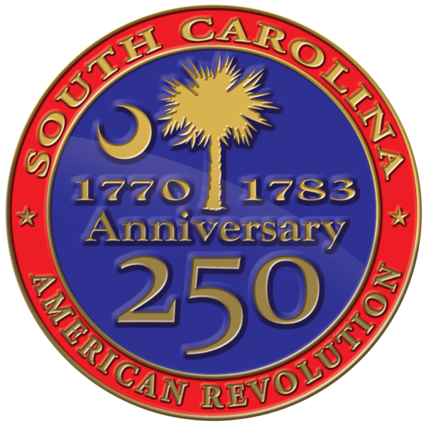
South Carolina American Revolution
Sestercentennial Commission
Minutes of the Full Commission Meeting
Friday, March 1, 2024 at 10:00 A.M.
Lancaster Historic Courthouse
104 N. Main St. Lancaster, SC 29720

SC250 Commission members were also all invited to a Tour of Revolutionary War sites in Lancaster County leaving from Andrew Jackson state park at 9:30a on Thursday, February 29, 2024. A Meet & Greet Reception at the Native American Studies Center of USC Lancaster was held that evening at 5:30 P.M. followed by an optional Dutch supper at local eateries or dinner on your own. All events were open to the public.

Present In Person
Commissioners:, Vice Chairman Bill Davies, Treasurer J. Brett Bennett, Jannie Harriot, Luther Lyle, Will Grimsley, Pam Cazel Advisors: Bill Segars, Perry Baker (SC Parks, Recreation & Tourism), Doug Doster (SC Society Sons of the American Revolution), Tom Persons and Julian Burns (SC American Revolution Trust), Diana Bramble (National Park Services), Chardonnay Ismail (Chernoff Newman Ad Agency), Guy Wallace, William (Buddy) Jennings Additional Attendees: Mahalie Davies, Jeff Kline, Kirk Johnson, Gina Bobo, Kip Carter, Gene Hetzel, Winnie Rickenbaker, Phil Gaines, Athena Ciulla, Laura Ledford, Sarah Jane Armstrong, Lorna Hainesworth, Jill J. Marshall, Rhett Adams, Mitchell Marcel, Johnathan Phipps, Joe Ridder, Greg Sligar, Harold Donnelly, Tim & Erica Lipsey, Allison Andrews, Lacy Ford, Harriet Futch Staff: Executive Director Molly Fortune, Grants Manager Heather Hawkins, Site Development Manager Mike Tyler, Program Coordinator Tyler Clark

Present Via Webex
Commissioners: Chairman Charles B. Baxley Advisors: Rick Wise (SCBPT) Additional Attendees: Chris Volf, Tracey Andrew, Courtney Corby, Pelham Lyles, Annie McIlhenny

Welcoming Remarks
Vice Chairman Bill Davies welcomed the crowd and opened the floor to the Lancaster Co. 250 Co-Chair Gina Bobo who thanked everyone who contributed to the previous day’s tour and celebrated the plans in Lancaster including 2-3 events a year. Commissioner Dianne Culbertson shared a moment in tribute to the late Doug Bostick of the SC Battlefield Preservation Trust.

Call to Order
Vice Chairman Bill Davies called the meeting to order at 10:18 am on March 1, 2024. Vice Chairman Davies confirmed there was a quorum of the Commission. Program Coordinator Tyler Clark confirmed that the public Notice of Meeting and Agenda had been posted at SC Dept. Archives & History and online in accordance with South Carolina’s FOIA.

Approval of Agenda
Vice-Chairman Bill Davies asked to approve the proposed agenda. Motion by Brett Bennett. Seconded by Dianne Culbertson and approved unanimously.

Public Comments
No one spoke during public comments.

Consent Agenda
Both the minutes from the December 1, 2023 meeting and August 30, 2023 meeting were on the consent agenda. Motion by Brett Bennett. Seconded by Will Grimsley and approved unanimously.

Introduction of Tyler Clark

Travel Reimbursement Policy
$.67 / mile

Statement of Economic Interest
Due by March 30, 2024

Awards & Recognition
A resolution to recognize Tony Small as a SC Humanitarian was approved unanimously with the motion made by Pam Cazel and seconded by Brett Bennett. A motion to create an ongoing Humanitarian Award in Tony Small’s honor was made by Pam Cazel and seconded by Dianne Culbertson before being approved unanimously.

Executive Director Updates
Vice Chairman Bill Davies updates that a committee/resolution has been set up in every county in South Carolina except Marion County. Bill anticipates it being full soon.

Tom Persons spoke about the South Carolina American Revolution Trust and the early success of the website. The Trust has received several donations and is looking for more.

Bill Segars updated the Commission on the SC250 Foundation. He started by saying the Foundation is different from the Trust because the Trust is more involved in spending money on the saving history for the future, as the Foundation is interested in receiving money from donors to use for current Commission needs. The foundation is currently working on its bylaws.

Pam Cazel introduced Cherokee Co. 250 guests Chairman of Cherokee 250 Tim Lipsey and Leighann Moon.

Renewal of Directors & Officers Insurance
A motion to allow the executive committee to approve a renewal or engagement of new carrier for directors and officers’ insurance (up to 20% increase) was made by Brett Bennett. Seconded by Will Grimsley and approved unanimously.

Executive Director Molly Fortune spoke about how SC250 plans to get visitors involved with the projects that the Commission is working on.

Ongoing & Upcoming Projects
Molly Fortune introduced Authenticity Brand Strategies. Authenticity met with several counties to help discover their assets and create plans to make these assets visitable. Another important factor was determined to be community assets that the counties can use to their advantage to help with their projects. The Gathering in Camden was announced for June 14, 2024 for counties to come together and ask questions and spread ideas.

Site Development Projects
Bill Segars announced that the South Carolina Department of Transportation has agreed to partner with South Carolina 250 to fund all new Revolutionary War marker ahead signs across South Carolina. Mr. Segars expressed his gratitude to SCDOT for helping this goal come true. The signs are 36 inches.

Three acres purchased in Calhoun County to be closed on in late March. Groundbreaking should take place in May to create a walking trail with places to park around Commodore Alexander Gillon’s gravesite. Plan is to have a ribbon cutting in August/September.

Approved Site Development Projects
- To design and buildout Parker’s Ferry (with SCBPT – Colleton Co.).
- To develop interpretation and access to Blackstock’s Plantation (with SCPRT – Union Co.).
- To improve access and interpret Stono Ferry (with SCBPT – Charleston Co.).
- To plan and develop Hammond’s Old Store (with SCBPT and Laurens County 250th Committee).
- To purchase land, plan, and develop site of Dunlap’s Defeat (with Abbeville County 250th Committee).

Archaeological Service
Archaeological services will be retained for work on locating and delineating the following sites:
- Wigging Hill (Allendale, Co);
- Long Canes (maybe Greenwood or McCormick.
- Brandon’s Defeat (Union, Co.);
- Mobley’s Meeting House (Fairfield, Co);
- Gen. Andrew Williamson’s White Hall house and fort (Greenwood Co);
- Col. James Williams’ Mt. Pleasant house and fort (Laurens or Newberry Cos.);
- Gen. Thomas Sumter’s Nelson’s Ferry Home (Clarendon Co.);
- and Oconee Town (Oconee, Co).

Grants
SC250 Grants Manager Heather Hawkins discussed the changes in the grant program to allow quicker review and implementation of grants. SC250 will continue to offer one $3,000 Non-Competitive Organizing Grant to each official County 250 Committee. SC250 also now offers Competitive Grants in the following levels Monthly Grants (up to $15,000), Major Grants ($15,001 to $125,000), and Premier Project Grants ($125,001+).

Monthly Grants get their name from the monthly review of applications with a deadline on the first business day of each month at 3:00 P.M. unless noted otherwise. Major Grants are reviewed quarterly. Premier Grants’ deadlines are also quarterly and will go through two rounds of review including a presentation to the full Commission or Executive Committee.

Each Competitive Funding Opportunity level will offer the following grant types: Local Museum Style Panel Grants, Local Activity Grants, County Asset Assessment & Historic Tourism Plan Grants, Research Grants, Publication Grants, Education Grants, Signage Grants, SC American Revolution Site Grants: Planning, Development, Renovation.

Upcoming Deadlines All deadlines are at 3:00 P.M. Eastern.
- Monthly Grants: 3/4/24, 4/1/24, 5/1/24, 6/3/24
- Major & Premier Project Grants: 3/26/24, 6/14/24
Grant applications must be submitted in the Discover SC WebGrants online portal. A new webinar was completed in January plus one on one consultations are available for anyone needing help.

Just a few applications came in under the new monthly grant deadline, but there has been a lot of interest in the new monthly review process for the $15,000 and below grants. The following grants were reviewed by external and internal reviewers and approved by the Executive Director following the first monthly grant deadline:
- $5,567 33rd Regiment of Foot Uniforms, Education & Recruitment
- $4,000 Updated interpretation at Buford’s Massacre Battlefield Site
- $5,900 Henry Laurens: A Life -Dr. Greg Brooking

Lunch

Committee Updates
Budget & Finance Committee
Commissioner Brett Bennett discussed the Budget FY24 vs Year to Date (February 12, 2024) spending.

Marketing, Branding, & Public Relations Committee
Commissioner Pam Cazel discussed the billboard trial in Cherokee, Camden, Abbeville, and Beaufort. The Commission learned a lot about what to do the same or differently in future advertising campaigns. The Charleston Tea Party was a massive success for all age groups and brought massive increases in local business revenue. Chardonnay Ismail from Chernoff Newman discussed how paid social media, digital display ads, and outdoor ads have reached over 10.3 million people. On digital media, the number reached is over 460,000.

Updates from Partners

National Parks Service (NPS) - Dianna Bramble discussed the record number of visitors that have visited South Carolina’s parks in the last year. Visitor spending also reached record numbers with the increase in visitors. In 2022, Cowpens had 212,534 visitors, Fort Sumter had 385,472 visitors, Kings Mountain had 238,656 visitors, and Ninety Six had 108,062 visitors. In 2023, Cowpens had an increase of 13,835, Fort Sumter had an increase of 26,272, Kings Mountain had a decrease of 19,389, and Ninety Six had an increase of 10,125.

Upcoming Meetings
The next full Commission meeting will be held on May 3, 2024, in Beaufort, SC with a Tour/Meet & Greet held Thursday, May 2, 2024.

Executive Session
Luther Lyles made a motion to go into executive session for site and partner contracts. This was seconded by Dianne Culbertson and approved unanimously.
A vote to return to open session was made by Brett Bennett and seconded by Dianne Culbertson and was approved unanimously. No action was taken.

Adjournment
Just before 2:00 P.M. Brett Bennett made a motion to adjourn. It was seconded by Will Grimsley and approved unanimously.

