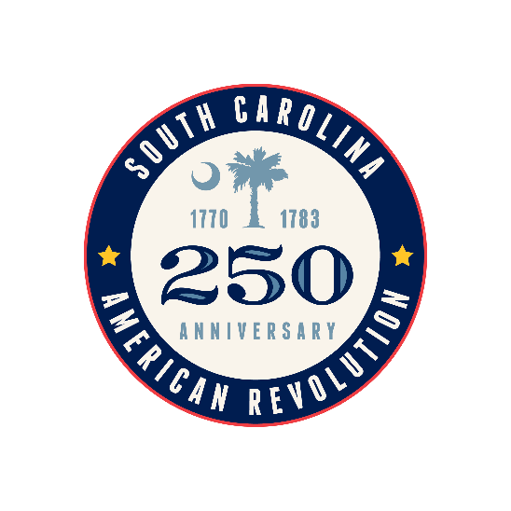
South Carolina American Revolution
Sestercentennial Commission
Minutes of the Executive Committee Meeting
Tuesday, December 10, 2024
Virtual Meeting

Present via Zoom for Commission Meeting
Commissioners: Commissioners: Chairman Will Grimsley, Vice Chairman Bill Davies, Treasurer J. Brett Bennett, Dianne Culbertson, Duane Parrish Additional Attendees: Andrew Cheatham (Ken Simmons Associates) Staff: CEO Molly Fortune, Sites Manager Mike Tyler, Grants Manager Heather Hawkins

Chairman Grimsley called the meeting to order around 2:00p. Vice-Chair Mr. Davies confirmed that we did have a quorum. Mr. Davies made a motion to accept the agenda, which was seconded by Mr. Bennett and was approved unanimously. It was confirmed that the Notice of Meeting and Proposed Agenda had been posted in compliance with FOIA.
Chairman Grimsley reported that he and Mr. Buddy Jennings spent a day at the State House meeting with House members. Mr. Jennings has a new associate who is a registered lobbyist who will be assisting with getting our message out. She has already helped to set up a meeting with Mr. Stavrinakis who is the Chair of the House Ways and Means Subcommittee to which we report.
He stated that he had been asked to include some bullet points for the State of the State to the Governor’s office.
He also had a chance to attend a Sons of the Revolution Evacuation Day Gala and make some connections and share awareness.
Ms. Fortune gave a few updates:
- The plan is to have a virtual County 250/Stakeholder Gathering in January and have another in person later in the spring.
- She requested a Virtual Commission meeting sometime in late January to help move some grants along.
- Ms. Fortune reported that she and Mr. Parrish with PRT had met and were looking at what the joint marketing might look like.
Drew Cheatham of Kenneth B. Simmons Associates, LLC presented a proposal regarding Revolutionary Heroes and Prison Ship Martyrs Memorial at Liberty Square in Charleston.
Discussion revolved around the conflict with the National Park Service which owns the space and the difficulties of getting an accurate list to include on the proposed signage.
Chairman Grimsley stated that step one is getting official approval from the National Park Service, which owns the park. Mr. Davies made a motion (seconded by Mr. Parrish) to send a letter to the NPS about the project in general (copying local NPS representatives) and get an official response about using Liberty Square for some type of American Revolution Memorial.
Chairman Grimsley will be meeting with state representatives at Santee Cooper Country this next week. Annie McDaniel is restarting the Rural Caucus and he has been invited to speak.
Motion to adjourn was made by Bill Davies around 2:49p, seconded by Dianne Culbertson, and approved unanimously.

