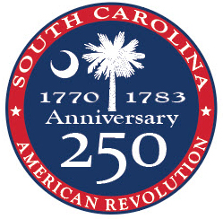
SC American Revolution Sestercentennial Commission
8301 Parklane Rd. Columbia, SC 29223 803-898-3392 SouthCarolina250.com

PHOTO RELEASE FORM

I, _____________________________[name], a presentative of __________________[organization], hereby grant SC American Revolution Sestercentennial Commission (SC250) and their succession designee my permission to edit, change, copy, and make any use of all photographs provided to SC250 for any legal use, including but not limited to publicity, copyright purposes, illustration, advertising, and web content.

Upon the usage of our photographs, I consent to such materials becoming the sole property of SC250 and that we will no longer be entitled to them, provided that it is done for lawful purposes.

Furthermore, I understand that no royalty, fee, or other compensation shall become payable to us due to such use.

Signature: ______________________________________________ Date _________

Printed Organization Name: ______________________________________________

Printed Representative Name: ____________________________________________

Phone Number: _______________ Email: ___________________________________

